ASSUMPTION UNIVERSITY
Vincent Mary School of Science and Technology

Department of Computer Science
Assignment 1 After Midterm Semester 1/2018

Deadlock management
- Define the term deadlock. Briefly describe the four conditions that can cause a deadlock in a system.
- Consider the resource allocation graph shown in Figure 1(where R₁, R₂, and R₃ are resources with 2 units each and P₁, P₂, P₃, and P₄ are processes):
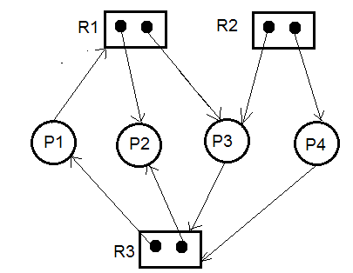
Figure 1
Attempt the graph reduction method and determine whether any deadlock exists or not (show all the steps of graph reduction).
- Describe the term ‘safe state’ in a resource allocation situation.
- The deadlock avoidance algorithm based on resource-allocation-graph is not applicable to a resource allocation system with multiple instances of each resource type (as in Figure 1). If so, then suggest and describe a suitable deadlock avoidance algorithm for a system with multiple instances of resources.
- Consider the following snapshot of a system (where P₀, P₁, P₂, P₃, P₄, A, B, C, and D are processes, and resources respectively):
Allocation Max Available Need
A B C D A B C D A B C D
P₀ 0 0 1 2 0 0 1 2 1 5 2 0
P₁ 1 0 0 0 1 7 5 0
P₂ 1 3 5 4 2 3 5 6
P₃ 0 6 3 2 0 6 5 2
P₄ 0 0 1 4 0 6 5 6
Answer the following questions using the banker’s algorithm:
5.1. What is the content of the matrix Need?
5.2. Is the system in a safe state? If yes, then show the safe state sequence.
5.3. If a request from process P₁ arrives for (0,4,2,0), can the request
be granted immediately?
Memory management
- Name two differences between logical and physical addresses.
- What is address binding? Describe the process of run-time address binding.
- Briefly describe the term dynamic loading. What is the main advantage of dynamic loading during a program execution?
- “Any attempt by a program executing in user mode to access operating-system memory or other users’ memory generates a trap (synchronous interrupt) to OS”. Briefly discuss how would the OS prevent the occurrence of a trap during the program execution?
- Assume that a user process with 100 MB in size and its backing store is a hard disk with a transfer rate of 50 MB per second. Calculate the context-switch time of the user process while it’s switching to or from main memory.
- Describe the terms external and internal memory fragmentations.
- What is the purpose of paging the page tables? Describe the advantage(s) of inverted page table over direct page table.
- A segment table with five segments and their memory limit and base values are shown in Table1.
Segment no. | Limit value | Base value
0 | 1000 | 1500
1 | 600 | 2600
2 | 1200 | 3500
3 | 1100 | 4750
4 | 400 | 6000
Table 1
Based on the segment table, show whether the following references to the byte locations of the segments would result a trap or not (if not, then show their physical addresses):
10.1. A location reference 1030tosegment 0
10.2. A location reference 300tosegment1
10.3. A location reference 1250tosegment 2
10.4. A location reference 300tosegment 4
- What is demand paging? Consider a virtual memory system with a page size of 128-bit and a physical memory of 256bytes (organization: 256 ×8). Each logical address has a 4-bit offset value. The page table is shown in Fig 2.
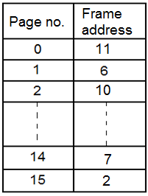
Figure 2
Based on the page table, calculate the physical addresses of the following logical addresses:
11.1. 12₁₆
11.2. 2A₁₆.
11.3. E7₁₆.
11.4. F2₁₆.
- What is page fault? Describe various steps taken by OS to handle the page fault.
- Assume that an average page-fault service time of 5 ms and a memory access time of 200 ns. If one out of 1,000 memory accesses cause a page fault, then calculate its effective-memory access time (EAT).
- Under what circumstances do page faults occur? Describe the actions taken by the operating system when a page fault occurs.
- Assume that a page reference string of a user process is “2 4 2 1 5 2 4 5 3 2 5 2” (means that the first page referenced is 2, the second page is referenced is 4, the third page referenced is 2, and so on.) and a three fixed memory-frames are allocated for this process. Show the performance of optimal, FIFO, and LRU page replacement algorithms in terms of their page fault.

