Lecture 04 Assignments
1) Create the circuit schematic of a 4-line Decoder using its truth table. Show the address ranges which are used to select four memory chips (each with size 16K × 8) by the decoder.
2) Create the circuit schematic of a adder using its truth table (show both half and full adders). Show a 4-bit adder/subtractor circuit from the full adders (show how it can perform a 4-bit addition and subtraction with the help of 4-bit numbers).
3) Describe how the adder/subtractor (from the question 2) can act as a 4-bit magnitude comparator.
4) Show the circuit schematic of a 2-bit multiplier and show a 2-bit multiplication on the multiplier with the help of 2-bit numbers.
5) [4 Points] Answer the following based on the circuit schematic which is shown in Figure1 (where A and B are two N-bit binary inputs and C_{out} is the carryout bit):
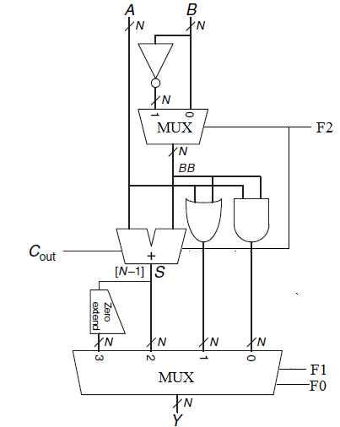
Figure 1.
5.1 (1 point) Identify the circuit.
5.2 (1 point) Find the output, Y when F₂ = 0, F₁ = 1, and F₀ = 0.
5.3 (1 point) Find the output, Y when F₂ = 1, F₁ = 0, and F₀ = 1.
5.4 (1 point) Find the output, Y when F₂ = 1, F₁ = 1, and F₀ = 0.
6) Sketch the schematics of an N-bit ALU (Arithmetic and Logic Unit) with four N-bit functions such as addition, subtraction, OR operation and parity checker.
7) Describe any three main differences between SRAM (Static Random Access Memory) and DRAM (Dynamic Random Access Memory). Show a 1-bit DRAM cell and explain its read and write operation.
8) Assume that a computer system has a 4Gbyte main memory (organization: 4G x 8). Show the maximum number of address bits which are used by the system to access the main memory.
9) Briefly describe the following terms:
9.1) Read Only Memory (ROM)
9.2) Erasable Read Only Memory (EROM)
9.3) EEPROM (Electrically Erasable Programmable ROM)
9.3) Flash memory

