Chapter 7 Assignments
- Define the term deadlock. Briefly describe the four conditions that can cause a deadlock in a system.
- “Deadlocks can be described more precisely in terms of a directed graph called a resource allocation graph”. Based on this description, show resource allocation graphs with and without deadlocks.
- Consider the following resource allocation graph (shown in Figure 1), attempt the graph reduction method and determine whether any deadlock exists or not (where R₁, R₂, and R₃ are resources and P₁, P₂, P₃, and P₄ are processes).
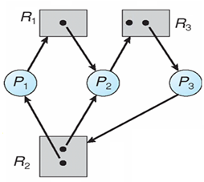
Figure 1.
- Consider the following resource allocation graph (shown in Figure 1), attempt the graph reduction method and determine whether any deadlock exists or not (where R₁, R₂, and R₃ are resources and P₁, P₂, P₃, and P₄ are processes).
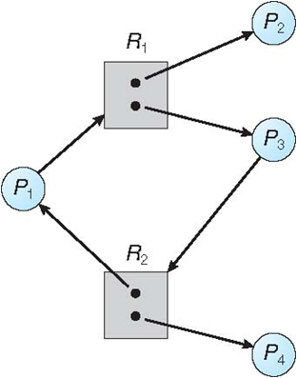

- Consider the following snapshot of a system (where P₀, P₁, P₂, P₃, P₄, A, B, C, and D are processes, and resources respectively):
Allocation Max Available Need
A B C D A B C D A B C D
P₀ 0 0 1 2 0 0 1 2 1 5 2 0
P₁ 1 0 0 0 1 7 5 0
P₂ 1 3 5 4 2 3 5 6
P₃ 0 6 3 2 0 6 5 2
P₄ 0 0 1 4 0 6 5 6
Answer the following questions using the banker’s algorithm:
5.1. What is the content of the matrix Need?
5.2. Is the system in a safe state? If yes, then show the safe state sequence.
5.3. If a request from process P₁ arrives for (0, 4, 2, 0), can the request be granted
immediately?
- Describe various options for breaking a deadloack.

