Lecture08- Assignment
- (4 Points) Consider the following segment table (shown in Table 1):

Segment | Base | Limit
0 | 216 | 600
1 | 2300 | 20
2 | 90 | 100
3 | 1327 | 510
Table 1.
Calculate the physical addresses (in decimal) of the following logical addresses:
1.1. [1 point] 0, 430
1.2. [1 point] 1, 20
1.3. [1 point] 2, 511
1.4. [1 point] 3, 400
- (3 Points) What is the purpose of paging the page tables? Describe the advantage(s) of inverted page table over direct page table.
- (4 Points) Consider a virtual memory system with a page size of 128-bit and a physical memory of 256 bytes. Each logical address has a 4-bit offset value. The page table is shown in Table 2.
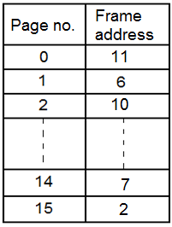
Table 2.
Based on the page table, calculate the physical addresses (in decimal) of the following logical addresses:
3.1. [1 point] 01₁₆
3.2. [1 point] 2B₁₆
3.3. [1 point] 1A₁₆
3.4. [1 point] FC₁₆
- (4 Points) “Any attempt by a program executing in user mode to access operating-system memory or other users’ memory generates a trap to OS”. Briefly discuss how would the OS protect the memory accesses during the program execution?
- What is address binding? Why is dynamic address binding more preferable in a computer system than static address binding?
- Consider a computer with a 32-bit virtual address (logical address) and a 4K-bit page size. How many entries are required in a page table? If each page table entry requires 4 bytes, what is the total size of the page table?

