F(x,y)=|x-y|
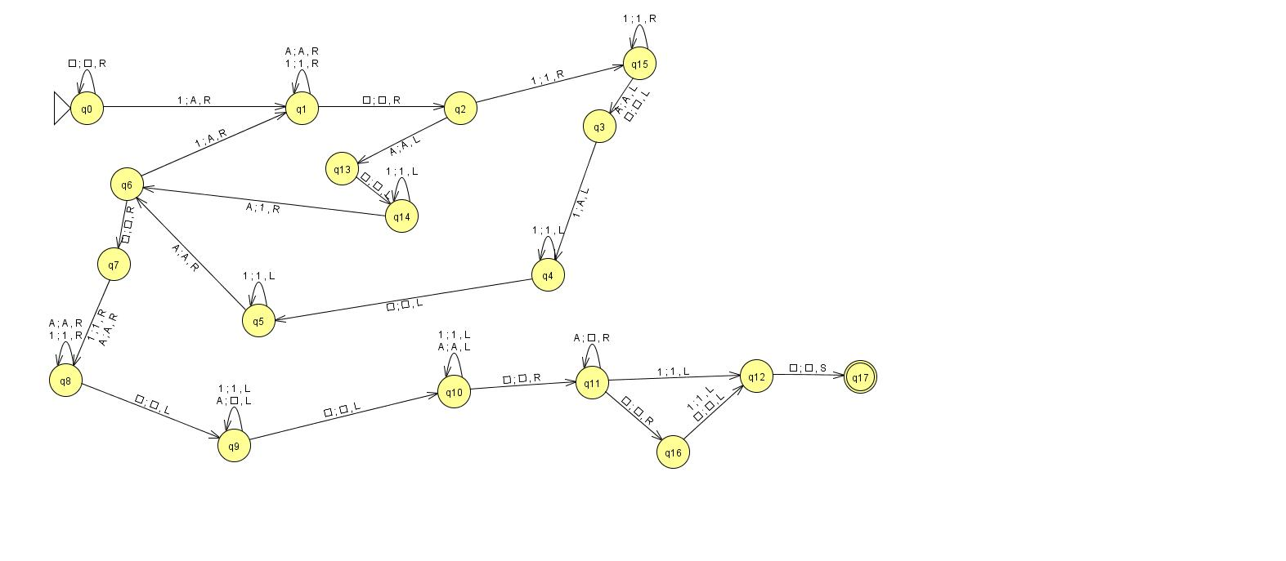

This machine start by match first "1" of left part and last "1" of right part if it match then mark them as "A" then continue until "1" of left or right part didn't match with other side anymore. Then change all "A" to empty symbol and move r/w head to the left most empty symbol before result.

Example input: 1111□111
□□1111□111□□ □□AAAA□AAA□□
□□A111□111□□ □□AAAA□AAA□□
□□A111□111□□ □□AAAA□AAA□□
□□A111□111□□ □□AAA1□AAA□□
□□A111□11A□□ □□AAA1□AAA□□
□□A111□11A□□ □□AAA1□AA□□□
□□AA11□11A□□ □□AAA1□A□□□□
□□AA11□11A□□ □□AAA1□□□□□□
□□AA11□11A□□ □□AAA1□□□□□□
□□AA11□1AA□□ □□AAA1□□□□□□
□□AA11□1AA□□ □□□AA1□□□□□□
□□AAA1□1AA□□ □□□□A1□□□□□□
□□AAA1□1AA□□ □□□□□1□□□□□□
□□AAA1□1AA□□ □□□□□1□□□□□□
□□AAA1□AAA□□

