Worksheet IV

1) Trace the value of each variable for the following Python code
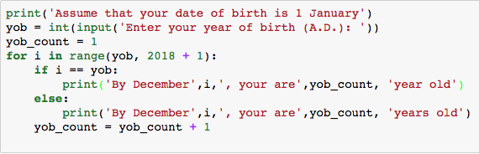
Assume that you will enter ‘2012’ as an input, start tracing at for i in range(yob, 2018 + 1).
Note: yob stands for ‘year of birth’

i | yob_count | if I == yob

- What is the purpose of yob_count = yob_count + 1 in this Python code? _______________________

2) Rewrite the above Python code using While-Loop?

3) Modify the Python code in 1) to generate the following outputs:
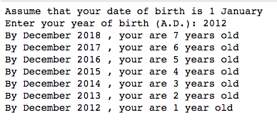
Hint: use range(start, end, -1) to start the range from a higher value down to a lower value with a
step -1. For example, range(5, 1, -1) is equivalent to 5, 4, 3, 2

4) Rewrite the Python code in 3) using While-Loop.

5) Try the following Python code and explain the difference between the value of variable, i, printed from the 1st and 2nd loop.
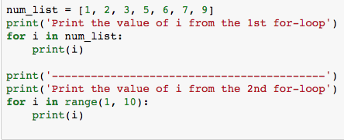

Discuss the difference between for ’i in num_list’ and ‘for i in range(1,10)’
_______________________________________________________________________________________
_______________________________________________________________________________________

6) What does the following Python code do?
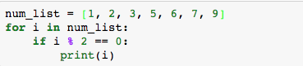
_______________________________________________________________________________________
_______________________________________________________________________________________
7) Modify the Python code in 6) to print an odd number that is higher than 5 from num_list.

8) Modify the Python code in 6) to print a number that is higher than or equal to 3, but less than 7.

9) Explain what the following Python code does
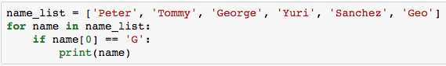

10) Modify the Python code in 9) to print a name from the name_list if the second character of the name is alphabet ‘e’.

11)
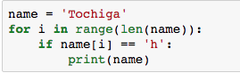
This for-loop will go through each character in the variable, name.

This Python code check if a character ‘h’ appears in the variable, name. If yes, it prints that name on the screen.

12) From 9) and 11), modify the Python code in 9) to print all the name in name_list that contains character ‘o’.

13)
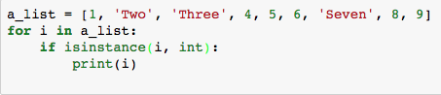
- What does the above Python code do?
- What is the purpose of the built-in function isinstance(x, int)? (Search the web to get the answer)

14) Modify the above Python code to print ‘Two’, ‘Three’ and ‘Seven’ on the screen.

