Worksheet V

Boolean expressions and nested conditions

Understanding Boolean and compound Boolean expressions
Expression | Meaning
x == y | True if x = y (mathematical equality, not assignment; otherwise, false
x < y | True if x < y; otherwise, false
x <= y | True if x ≤ y; otherwise, false
x > y | True if x > y; otherwise, false
x >= y | True if x ≥ y; otherwise, false
x != y | True if x ≠ y; otherwise, false
Examples
10 < 20 True
10 >= 20 False
x < 100 True if x Is less than 100; otherwise, False
x != y True unless x and y are equal

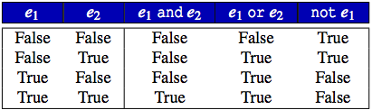

Operator not has higher precedence than both and and or.
and has higher precedence than or.
and and or are left associative; not is right associative.
and and or have lower precedence than any other binary operator except assignment.

1) Fill in the blank
x = 10
y = 20
b = (x == 10) # assigns True to b
b = (x != 10) # assigns False to b
b = (x == 10 and y == 20) # assigns ________ to b
b = (x != 10 and y == 20) # assigns ________ to b
b = (x == 10 and y != 20) # assigns ________ to b
b = (x != 10 and y != 20) # assigns ________ to b
b = (x == 10 or y == 20) # assigns ________ to b
b = (x != 10 or y == 20) # assigns ________ to b
b = (x == 10 or y != 20) # assigns ________ to b
b = (x != 10 or y != 20) # assigns ________ to b

2) Given the following definitions
x = 3, y = 5
b1, b2, b3, b4 = True, False, x == 3, y < 3

Evaluation the following Boolean expressions
b1 and b2 ______________
b1 or b2 ______________
b1 and b3 ______________
b1 or b3 ______________
b1 and b4 ______________
b1 or b4 ______________
b2 and b3 ______________
b2 or b3 ______________
b1 and b2 or b3 ______________
b1 or b2 and b3 ______________
b1 and b2 and b3 ______________
b1 or b2 or b3 ______________
not b1 and b2 and b3 ______________
not b1 or b2 or b3 ______________
not (b1 and b2 and b3) ______________
not (b1 or b2 or b3) ______________
not b1 and not b2 and not b3 ______________
not b1 or not b2 or not b3 ______________
not (not b1 and not b2 and not b3) ______________
not (not b1 or not b2 or not b3) ______________

3) Write a Python program to take name, height and weight. Then calculate Body Mass Index (BMI) and show if the person is normal or has obesity (range of BMI is shown in the following figure). Note that exercise 12 in worksheet III illustrates how BMI is calculated.

Examples of input and output

4) Write a Python program that takes a month (e.g., Jan, Feb, etc.) and print on the screen in which quarter the entered month is. For example, if January is entered, the output is “January is in quarter 1”.

5) Write a Python program to take name, gender, age and print out the growth stage of the person.

Age | Growth Stage
< 11 | Children
11 to 17 | Adolescence
18 to 40 | Young adult
41 to 65 | Adult
> 65 | Elderly

Examples of inputs and outputs

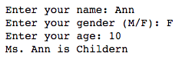

6) Try the following Python code.
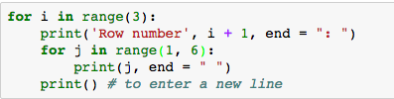

- Modify the code to print 10 rows each with values 1 to 10.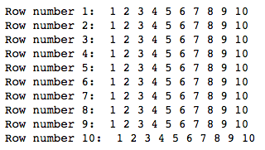

- Modify the code again to print odd rows (rows 1, 3, 5, 7 and 9) with even values (2, 4, 6, 8, 10) for each low.

7) Write a Python program to print the following multiplication table :

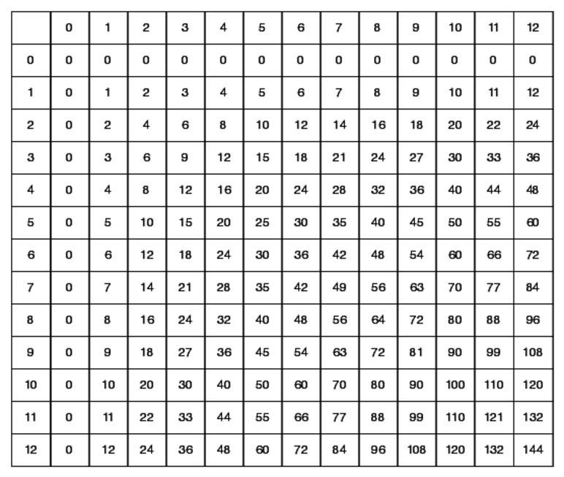

8) Write a Python program to calculate a dog's age in dog's years.

Note: For the first two years, a dog year is equal to 10.5 human years. After that, each dog year equals 4 human years.

