Worksheet VI

More on loops, conditions, Boolean expressions

1) The following Python code takes three inputs, namely num1, num2 and num3, and then prints the largest among the three input values.

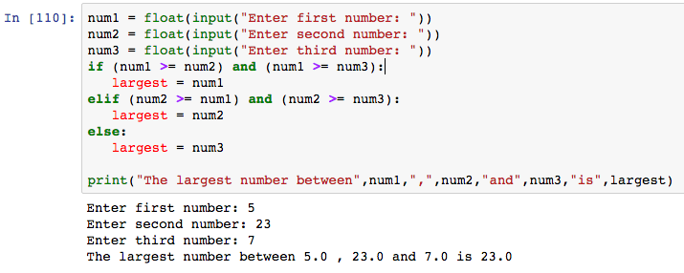

- Modify the code to print the smallest value among the three input values. You must use eval( ) function to take the three inputs.

2) The following Python code takes two inputs, namely name and age. Then the code calculates the number of Chinese zodiac cycles you have lived. Fill in the blank below.

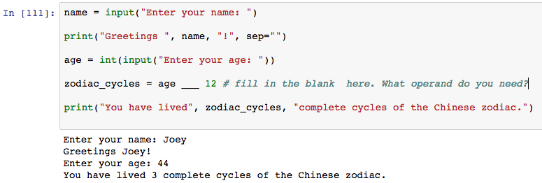

- What operand do you need? _________________

3) Try the following Python code which receives two inputs, namely name and yourid. The code asks whether or not you want to have your name and id printed on the screen. This operation continues until you enter either n or N to end the program.

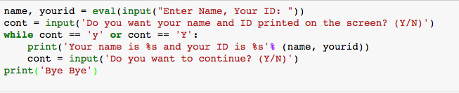

4) Write a Python code to calculate BMI and the code keeps asking you to continue until you enter n or N to end.

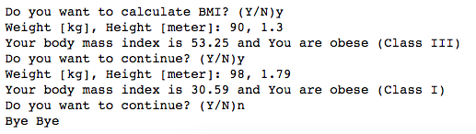

5) Try the following Python code and observe the result.

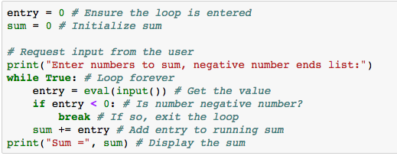

- Which condition does cause a while-loop to break? ______________________

- Modify the code to take n or N in order to end list and calculate sum.

6) Write a Python code to calculate your saving when you retire. The code takes 3 inputs; your current age, your retirement age and your saving per month. The code should print your saving per year starting from a current year to a retirement year. (Check exercises 13 and 14 in worksheet III for reference)

- Complete this exercise using for-loop
- Complete this exercise using while-loop

7) The following Python code takes multiple inputs and stores them in a list.

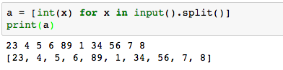

- Write a Python code that takes multiple inputs and prints out the maximum, minimum and average values.

- Write a Python code that takes multiple inputs and asks if a user prefers to find a sum of either odd, even or all numbers (your code must show a user three options to choose) and print the value on the screen.

- Write a Python code that takes multiple inputs and prints all the values which are greater 10 but less than 50. The number must be even number and divisible by 6 (for example, 12, 18, 24).

