Worksheet VI

Loops, conditions, Boolean expressions continued

For exercises 1 – 6, try to answer all the questions without coding. Once you have answered all the questions, do the coding to crosscheck your answers. This is important for your practice as you will need to solve this kind of questions without being able to do the coding during the written examination.

1) Consider the following Python code that prints one line of text:

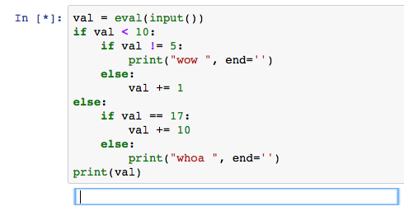

- What will the program print if the user provides the following input?

(a) 7 _________

(b) 22 _________

(c) 5 _________

(d) 17 _________

(e) – 3 _________

2) How many asterisks does the following code fragment print? ______
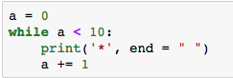

3) How many asterisks does the following code fragment print? _______
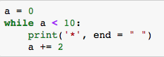

4) How many asterisks does the following code fragment print? _______
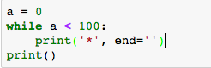

5) How many asterisks does the following code fragment print? _________
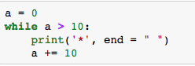

6) How many asterisks does the following code fragment print? __________

How many asterisks per row? _______ How many row? _________

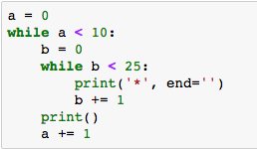

7) The following Python code takes a single value integer and print the number of * characters in accordance with the value entered. For example,

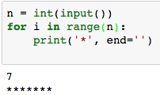

- Write a Python code that takes a single integer value. If the value entered is less than one, the program prints nothing. If the user enters a positive integer, n, the program prints an n×n box drawn with * characters. If the users enter 1, for example, the program prints

*

If the users enter 5, the program prints

****

****

****

****

8) The following Python code takes temperature from a user and put all numerical characters in variable degree and character in variable i_convention. 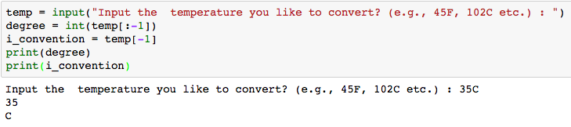
- Write a Python program to convert temperatures to and from celsius, fahrenheit.

[ Formula : c/5 = f-32/9 [ where c = temperature in celsius and f = temperature in fahrenheit ]

Expected Output :
60C is 140 in Fahrenheit
45F is 7 in Celsius

9) The following Python code checks if variable name (‘Jane’) appears in which list.

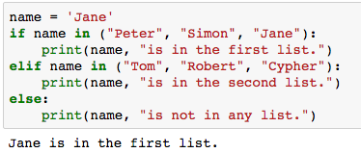

The following Python code takes name of month as an input and print the number of days of the entered month

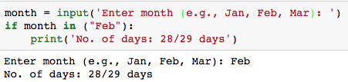

- Complete the Python code for other months.
Expected Output:

List of months: Jan, Feb, Mar, Apr, May, Jun, Jul, Aug, Sep, Oct, Nov, Dec

Enter month (e.g., Jan, Feb, Mar): Aug

No. of days: 30 days

10) The following Python code counts the number of alphabets from the string you enter.

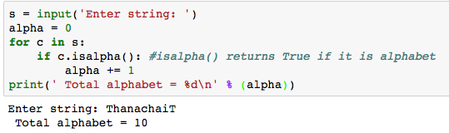

Note:

isalpha( ) returns True if it is an alphabet.

isupper( ) returns True if it is an uppercase letter

islower() returns True if it is a lowercase letter

isdigit() returns True it is a numeric

- Modify the code to print the total number of alphabets, uppercase letters, lowercase letters, numeric and other letters. The output should be

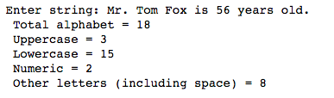

11) The following Python code prints duplicated if any of the values in the list x is duplicated.

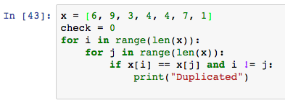

- Write a Python code that requests five integer values from the user. It then prints one of two things: if any of the values entered are duplicated, it prints "DUPLICATED"; otherwise, it prints "ALL UNIQUE".

12) Based on exercise 11, write a Python code that takes a word as an input and checks if there are duplicated characters. The expected outputs are:

