- Write a Python program that takes an input a (integer value) and then print only even number starting from 2 to a and the numbers are not a multiple of 3. Then print the numbers that are a multiple of 3 on a separate line.

Example:
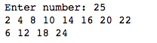

- (4 marks) Write a Python program that takes your salary, your savings (in percentage) per month, your current age using eval( ). Then calculate the total savings when you are retired. The retirement age is 60 years. Print your savings per year until your retirement age. If the total saving is greater than 1,000,000 baht, print “Your total saving is xxxx Baht and are now a rich man.”. Otherwise, print “Your total saving is xxxx Baht. You need more savings for your retirement.”.

Example of inputs and outputs.

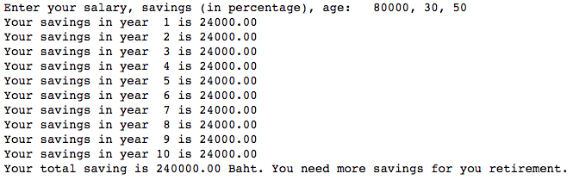

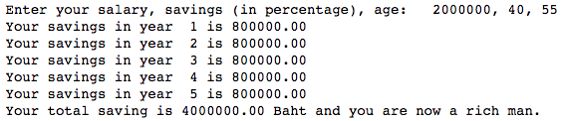

- (4 marks) Write a Python program that takes words from a user and print the total number of vowel letters (a, e, i, o and u, both uppercase and lowercase letters) found in the entered words.

Examples of inputs and outputs.

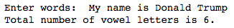

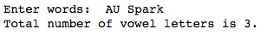

- (5 marks) Write a Python program to take your age, gender and fat percentage using eval( ). Then print out your health condition, e.g., underfat, ideal or overfat, according to the following table.

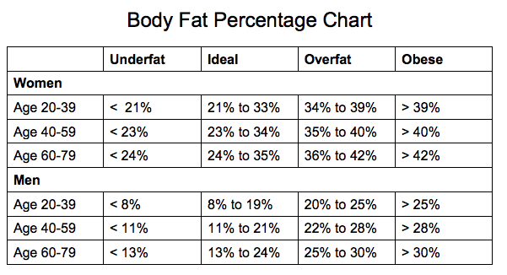

Examples of inputs and outputs

