Worksheet VIII

Introduction to functions in Python

Find out on the Internet what the purpose of coding (or writing) a function in Python

There are also built-in functions in Python. What is a built-in function? Give few examples.

- The following example show how to write a simple Python function and will triple the value that is entered into the function.
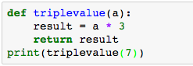

- Try print(triplevalue(2)), print(triplevalue(5))

- The following function takes two inputs; a and b, and find the sum of the two values
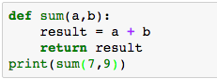

- Write a Python function to take three inputs and find the average value.

- Fill in the blank to compute factorial of 4
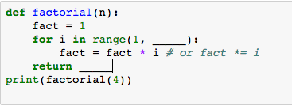
First blank? __________
Second blank? _____________

- Find whether print(factorial(4)) operates inside or outside def factorial(n)? ______
- Compute 6!, 10!, 0! using the same function in exercise 1).
- Try
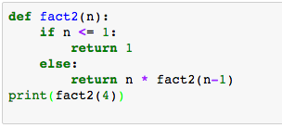

- Take note the differences between functions factorial(n) and fact2(n) in exercises 1) and 2), respectively.
____________________________________________________________________________________________________________________________________________________________________
__________________________________________________________________________________
__________________________________________________________________________________

- Try
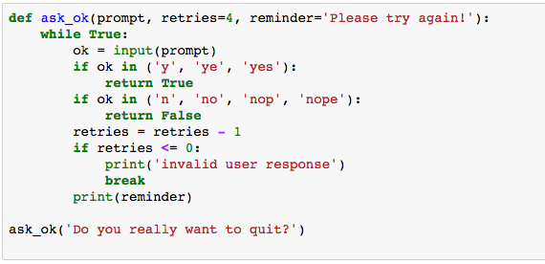

- How many attempts can you try if you do not answer correctly (e.g., enter any character other than ‘y’ or ‘n’)? ___________________
- Which argument in function ask_ok() does determine the number of attempts? _______
- How many arguments are there in function ask_ok()? _________

Try
ask_ok('OK to overwrite the file?', 2)

- What do you observe here in terms of number attempts?
__________________________________________________________________________________

Try
ask_ok('OK to overwrite the file?', 2, 'Come on, only yes or no!')
- What do you observe here? ________________________________________________________

What do you observe from the number of arguments you can enter when you call a function? _____________________________________________________________________________________

- Write a function simplemath( ) that takes three arguments, namely a, b, and op. Then write a Python program that takes two inputs and one operand (+, -, *, /) and print the output value of the operation of a and b.

- x = [3, 1, 56, 34, 23, 100, 10], write a function that sorts list x and print it out.

- From list x in the exercise 7), try sorted(x) and sorted(x, reverse=True)

Also try, x.sort() or x.sort(reverse=True), then print(x)

- What is the purpose of the given function?

What is the purpose of float(‘inf’)? Search the answer from the Internet.

def second_smallest(numbers):
a1, a2 = float('inf'), float('inf')
for x in numbers:
if x <= a1:
a1, a2 = x, a1
elif x < a2:
a2 = x
return a2
print(second_smallest([1, 2, -8, -2, 0]))

- Write a function that find the second largest value in the given list.

