Worksheet XI

Introduction to Flowchart
Flowchart is a diagrammatic representation of an algorithm. Flowchart are very helpful in writing program and explaining program to others.

Basic Symbols Used in Flowchart

Different symbols are used for different states in flowchart, For example: Input/Output and decision making has different symbols. The table below describes all the symbols that are used in making flowchart
Symbol | Purpose | Description
 | Flow line | Used to indicate the flow of logic by connecting symbols.
 | Terminal(Stop/Start) | Used to represent start and end of flowchart.
 | Input/Output | Used for input and output operation.
 | Processing | Used for airthmetic operations and data-manipulations.
 | Decision | Used to represent the operation in which there are two alternatives, true and false.

Example of flowchart for if-elif-else code.

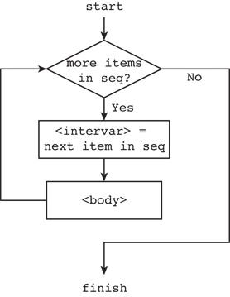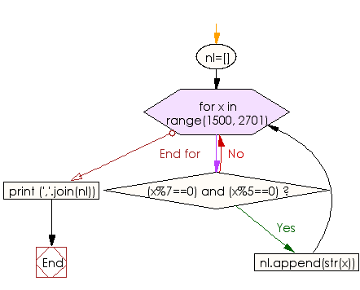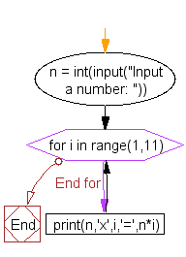
Example of flowchart for for-loop

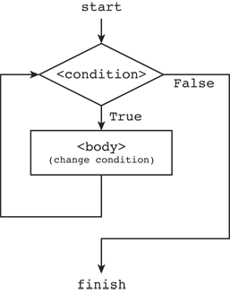
Example of flowchart for while-loop

Examples of flowcharts in programming
Draw a flowchart to add two numbers entered by user.
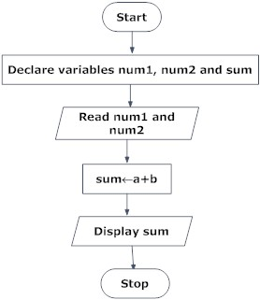

Draw flowchart to find the largest among three different numbers entered by user.
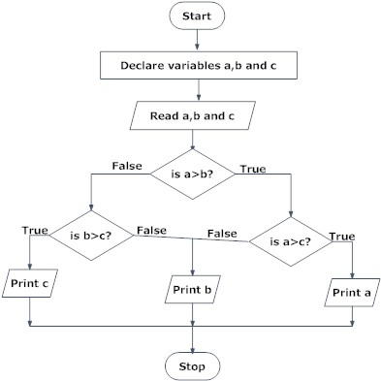
Though, flowchart are useful in efficient coding, debugging and analysis of a program, drawing flowchart in very complicated in case of complex programs and often ignored.

Exercises:
1) Draw a flowchart for the following Python code.
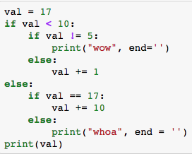

2) Draw a flowchart for the following Python code.

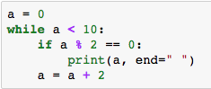

3) Draw a flowchart for the following Python code.

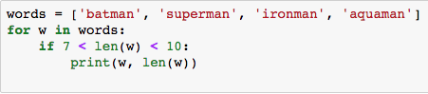

4) Draw a flowchart for the following Python code.

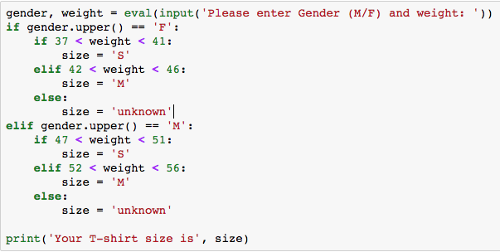

5) Write a flowchart for the following Python code.

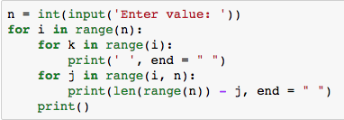

The give flowchart can be translated back to the following Python code.
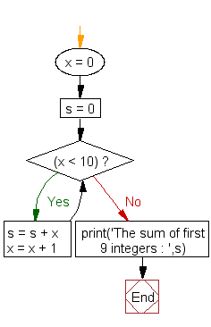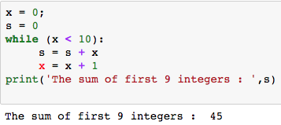

6) Write the Python code based on the given flowchart.
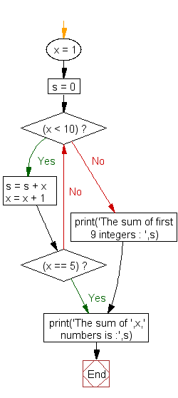

7) Write the Python code based on the given flowchart.
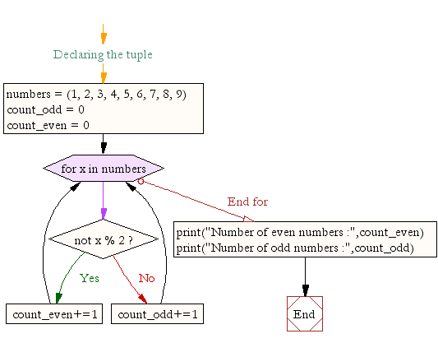

8) Write the Python code based on the given flowchart.

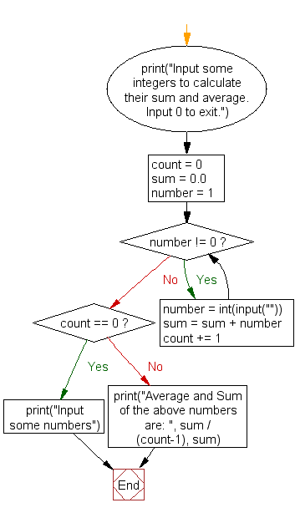
End of while-loop and continue here here
While-loop here

