Worksheet I

Get started with Jupyter Notebook. 1) Run Jupyter notebook and 2) click New (right side) and choose Python 2 option.

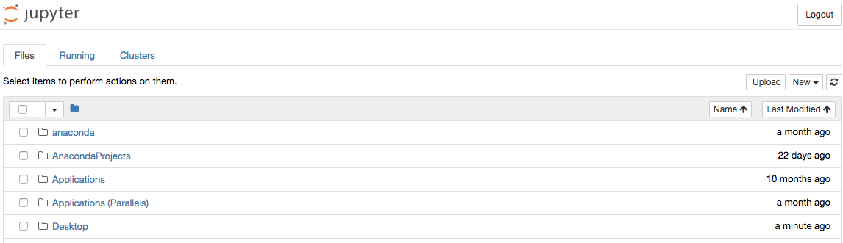

A new browser tap is created as shown in the example below.

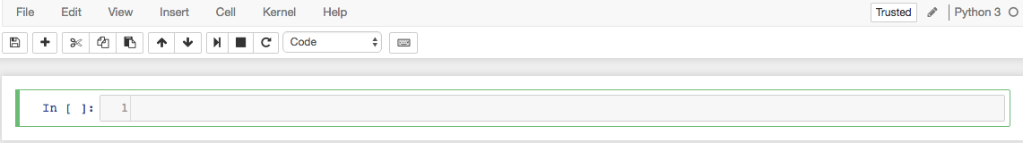

Try rename your notebook and use the following naming convention.

Yourid_1_2018_worksheetX

For example,
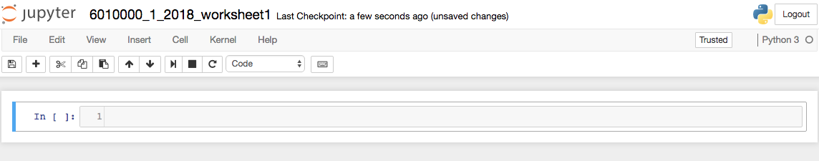

In the Jupyter notebook cell, type print(“Hello IT students!!!!”) and click run button . The output will immediately be shown below the cell (where you put your code). For example,

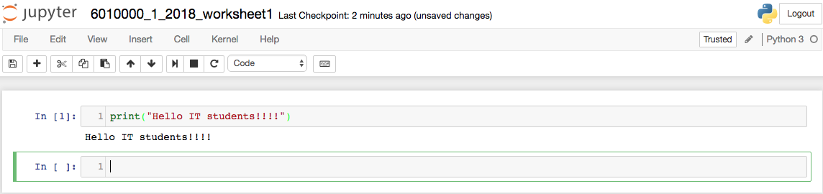

Try the following exercises.

- Find the answer (do it manually)
2 + 2 - 3 = ______
50 – 5 * 4 = ______
(50 – 5 * 6) / 4 = ______

At your screen (Jupyter notebook) cell, try the followings (one at a time) and see the results.

2 + 2 - 3
50 – 5 * 4
(50 – 5*6) / 4

Do you observe any difference among the three results (hint: type of variable)?
_______________________________________________
Note: Python supports various types of variables such as integer (int), floating point (float), string (str) etc.

- 19 / 3 # classic division returns a float
19 // 3 # floor division discards the fractional part
19 % 3 # the % operator returns the remainder of the division
6 * 3 + 1 # result * divider + remainder

Search on the Internet to see what this sigh ‘#’ is for in Python. ___________________________________
- Try
tax = 12.5 / 100
price = 200.50
tax * price

- Try
x = [3,20,41,710,-92,108] # x is a list containing Integer values
print (x)
Then try the followings to observe the results.
- print (x[0])
- print (x[1], x[3], x[5])

If you observe carefully, indexing in Python programming language starts at 0.

Fill in the blank (answer the following questions in this worksheet)
x[__] = 710
x[1:] = ______________
x[:4] = ______________
x[__:__] = [20,41]

Note: x[1: ] # integers from position 1 (included) to the end
x[:4 ] # integer from the beginning to position 4 (excluded)

- Try each of the followings and click run.
‘Goodbye World’
“Goodbye World”
‘It isn’t’
‘It isn\’t’
What do you observe for the single quotation mark? _________________________________

Try
s = 'First line. \nSecond Line'
print('First line. \nSecond Line')
print(s)

Try
print('C:\some\name')

What do you observe from the output? ___________________________________________
Try
print(r'C:\some\name') or print(r'C:\some\\name')

- Try
prefix = 'Hell' # prefix is a variable with string type. You can merge/join two strings using +
word = prefix + 'o'
print(word)

Try
print(word[:2])
print(word[2:5])

Try
print(word[:2] + word[2:5])

Try
print('J' + word[1:])

- Write a code to replace ‘llo’ with ‘at’ in the variable word. So the outcome should change from ‘Hello’ to ‘Heat’

myid = 6015555
print('My student ID is', myid)

- y = ['hello', 'good', 'morning', 'bye', 'hi', 'afternoon'] # y is a list containing a number of strings
y[5]
print(y[5])
Observe the difference in the outputs? __________________________________
print (y[1],y[5])

Based on the above list, fill in the blank
y[ ] = 'hello'
y[2:] = _________________
y[:4] = _________________
y[ : ] = ['good', 'morning', 'bye']

- Try
x = [3, 10, 41, 810, -92, 18]
for a in x:
print (a)

Try putting ,either end=" " or end=", " after variable a (print(a, end = “ ”)). What do you observe? ________________________

What if for a in x: is changed to for a in x[1:5]: ? ___________________

Try
x = [3, 10, 41, 810, -92, 18]
for a in x[1:3]:
print (a)
for a in x:
print(a)

Try
x = [3, 10, 41, 810, -92, 18]
for a in x[1:3]:
print (a)
for a in x:
print (a)

What do you observe from the outputs?__________________________________________
_____________________________________________________________________________
_____________________________________________________________________________

Try

x = [3, 20, 41, 710, -92, 108]
for a in x:
print (a)

- Adjust the program to print only the 2nd (20) to the 5th (-92) numbers in list x
- Adjust the program to print only the numbers in the odd positions (1st, 3rd, … )

- Try
list(range(10)), and click run
list(range(0,10,2)), and click run

Fill in the blank
list(range(10)) = _________________________________________
list(range(2,9)) = ________________________________________
list(range(2,15,3)) = ______________________________________
list(range(__)) = [1,3,5,7,9,11,13]
list(range(__,__)) = [11,12,13,14,15]
list(range(__,__,__)) = [9,11,13,15,17,19,21,23]
list(range(5,0,-2)) = ____________________________________

Fill in the blank
list(range(15,11)) = _________________
list(range(__,__,__)) = [15, 14, 13, 12, 11, 10]

- y = [9,11,13,15,17,19,21,23]
print(len(y))

Fill in the blank
len(range(2,20,2)) = ______________________

- What is the purpose of function len( )? _________________________________________

Try, list(range(len(y))) = ______________________________________________
With the following exercises, you will learn how a Python takes inputs from the keyboard using input( ) function.

- a = input('a = ')
b = input('b = ')
print (a, b)
print (a+b) # statement 1

a = int(input('a = '))
b = int(input('b = '))
print (a, b)
print (a+b) # statement 2

- What do you observe for the outputs from statement 1 and statement 2? ______________________________________________________________

- Try creating some other variables (x, y, Mynumber, etc.) and assign values to them.

- Write a program that takes numbers a and b. Then print every number from a to b. Hint: use for-loop with range( ).

- for i in range(10):
if i % 2 == 0:
print (i, end=” ”)

The above code prints all even numbers between 0 and 10. Which statement (code) does it tell that the number is an even number? __________________________________________________

- Write a program that prints every number from 0 to 50 that is a multiple of 5.

- Write a program that takes numbers a and b. Then print every odd number from a to b.

- Write a program that takes numbers a and b. Then print every number squared from a to b. (for powering, use ** operator)

- Write a program that takes numbers a and b. The value of a must be greater than that of b. Then print every number from a down to b.

- Write a program that takes your name and your student ID. Also takes the number of times you want to print your name and your student ID. Then print them out.

