CS1201 Sec. 543 Quiz I

Answers are in RED.

Fill in the blank
1. x = [1, 3, 5, 7, 9, 11, 13]
x[3] = ___7______
x[-1] = ___13_____

2. list(range(_9_,_26_,_4_)) = [9 ,13, 17, 21, 25]

3. len(list(range(2, 10, 3) = __3___

4. Trace the following Python program.
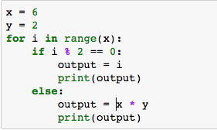
i | x | y | output | i%2 ==0  (True or False)
2 | 6 | 2 | 2 | True
3 | 6 | 2 | 12 | False
4 | 6 | 2 | 4 | True

5. Complete the following code in order to produce the outputs shown below.
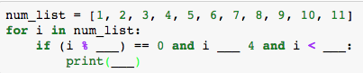
The outputs are
6
8
if ( i % 2) == 0 and i > 4 and i < 9:
print(i)
Since the outputs are 6 and 8, that means the outputs are even numbers that is greater than 4 and less than 9 (or you can say less than 10).

