Worksheet IV

1) Trace the following Python code and determine the variables’ value for each for-loop.
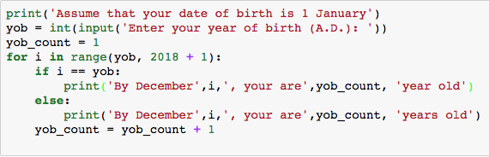
Assume that you will enter ‘2010’ as an input, start tracing the Python code when the value of variable i is as follows:
Note: yob stands for ‘year of birth’

i | yob_count | if i == yob
2012
2013
2014
2015

- What is the purpose of yob_count = yob_count + 1 in this Python code? _______________________
________________________________________________________________________________________

2) Rewrite the above Python code using While-Loop.

3) Modify the Python code in exercise 1) to generate the following outputs:
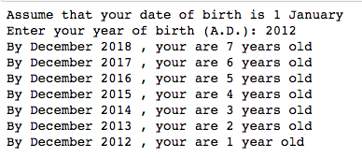
Hint: use range(start, end, -1) to start the range from a higher value down to a lower value with a
step -1. For example, range(5, 1, -1) is equivalent to 5, 4, 3, 2

4) Rewrite the Python code in exercise 3) using While-Loop.

5) Try the following Python code and explain the difference between the value of variable i printed from the 1st and 2nd loop.
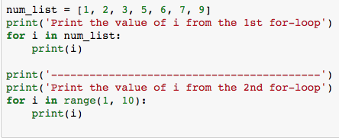

Discuss the difference between for ’i in num_list’ and ‘for i in range(1,10)’
_______________________________________________________________________________________
_______________________________________________________________________________________

6) What does the following Python code do?
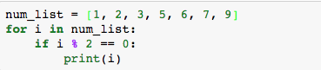
_______________________________________________________________________________________
_______________________________________________________________________________________

7) Modify the Python code in exercise 6) to print an odd number that is higher than 5 from num_list.

8) Modify the Python code in exercise 6) to print a number that is higher than or equal to 3, but less than 7.

9) Explain what the following Python code does
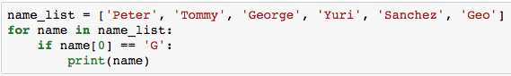

______________________________________________________________________________________
______________________________________________________________________________________
______________________________________________________________________________________

10) Modify the Python code in 9) to print a name from the name_list if the third character of the name is alphabet ‘o’ and ‘i’.

11)
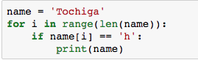
This for-loop will go through each character in the variable, name. It then checks if a character ‘h’ appears in the variable, name. If yes, it prints that name on the screen.

12) Based on exercises 9) and 11), modify the Python code in 9) to print all the name in name_list that contains character ‘o’.

13)
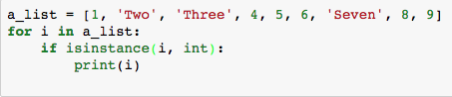
- What does the above Python code do?
- What is the purpose of the built-in function isinstance(x, int)? (Google to find the answer)

14) Modify the above Python code to print ‘Two’, ‘Three’ and ‘Seven’ on the screen.

15) Try the following Python code.
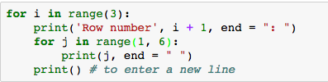

- Modify the code to print 10 rows each with values 1 to 10.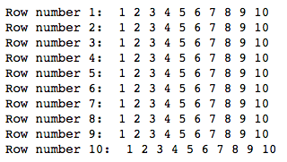

- Modify the code again to print odd rows (rows no. 1, 3, 5, 7 and 9) with even values (2, 4, 6, 8, 10) for each low.

