Worksheet V

Nested If-else
The if...else statement executes two different codes depending upon whether the Boolean expression (if-else condition) is true or false. Sometimes, a choice has to be made from more than 2 possibilities. The nested if...else statement allows you to check for multiple test expressions and execute different codes for more than two conditions.
As an example, in Python (or any other programming language), there may be a situation when you want to check for another condition after a condition resolves to true. In such a situation, you can use the nested if construct. In a nested if construct, you can have an if...elif...else construct inside another if...elif...else construct.
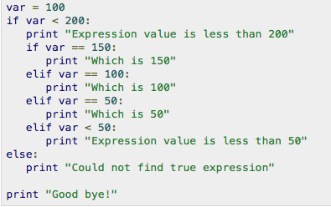
- In the above example, what would be printed on the screen? __________________________________________________________________________________
- Write a Python code to take 2 numbers for variable names, var1 and var2. If the value of var1 is equal to that of var2, print “(value of var1) is equal to (value of var2)”. For example if you enter 8 and 8 for var1 and var1, the code will print “8 is equal to 8”. The code will print “(value of var1) is greater than (value of var2)” if var1 > var2, and vice versa. Solve this problem using nested if-else. Hint: you should first check if the two values are not the same, then you can if another if-else to check if var1 > var2 or var2 > var 1 under the first if statement.
- The following table illustrates the grip strengths (on average) based on Gender. In general, the dominant hand will often score 10 percent higher than the non-dominant hand. Write a Python code to take a gender (capital M or F) and grip strength in kg. and then print out the strength level. For example, if you enter M and 50 as inputs, the code should print “Your grip strength is average.”
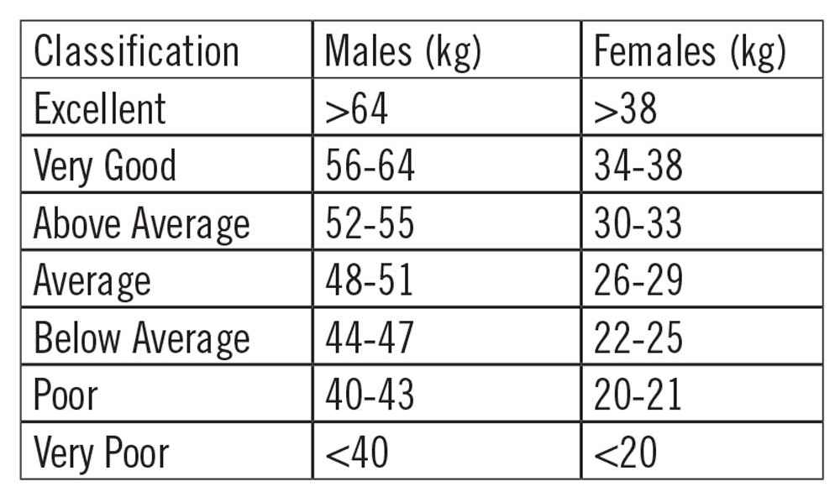
- Write a Python program to take name, gender, age as inputs and print out the growth stage of that person.
Age | Growth Stage
< 11 | Children
11 to 17 | Adolescence
18 to 40 | Young adult
41 to 65 | Adult
> 65 | Elderly

Examples of inputs and outputs

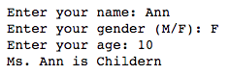
- The following figure (as of 2014) shows the average annual salary for data scientists and analytics professionals jobs based on years of experience. Write a Python code the take name, job title (either “AP” or “DS” for Analytics Professionals and Data Scientists, respectively) and years of experience, then print out the average salary according to the following figure. For example, if you enter Tom, AP and 5, the code will print “Tom’s annual salary is 85,000 USD.”

For your information, the following figure gives information related to average salary for different Big Data job in year 2018. See how much you can earn when you graduate with the right skills.
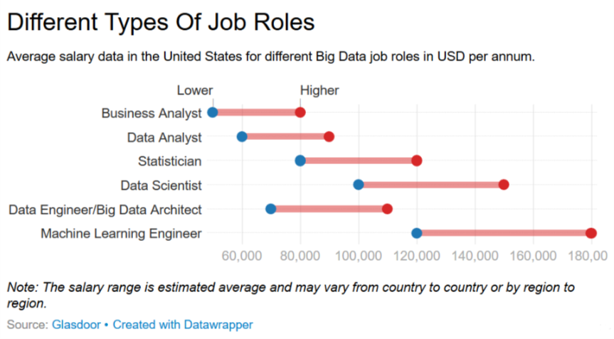

More exercises for If-else, nested if-else and looping
- Write a Python program to take dog’s age as input and calculate a dog's age in human’s years. Note: For the first two years, a dog year is equal to 10.5 human years. After that, each dog year equals 4 human years.
- Write a Python code that takes two integers, a and b. Then print all integer between these two numbers (including a and b). Note that any integer ended with 8 will be replaced by *. For example, if you enter 2 and 12 for a and b, the code will print

2 3 4 5 6 7 * 9 10 11 12

If you enter 10 and 29, the code will print

10 11 12 13 14 15 16 17 * 19 20 21 22 23 24 25 26 27 * 29

- Write a Python code to print all integer numbers between 0 and 100 with the following conditions:
  - All numbers must be divisible by 3, and
  - the number between 20 – 40 and 60 – 80 will not be printed.

- Write a Python code that prints integers between 100 and 400 so that all digits in the printed integers must be even number (assume that 0 is also an even number). For example, the printed integers must be 200 or 222 or 246. The printed number should not include an odd value in any digits such as 124 or 219.

- Write a Python code to print integers between 100 and 200 with the following conditions:
  - The right-most digits must be even number,
  - the integers that is divisible by 5 will not be printed,
  - 0 is considered as an even number, and
  - all the printed integers between 130 – 140 and 160 – 170 will be replaced by @ sign.

- Based on the given Python code, modify the code to print the number where all digits are even number. Otherwise, -- will be printed as shown in the expected output below.
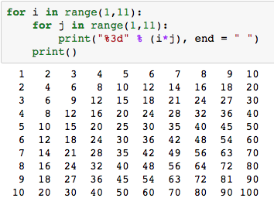

Expected output
