- x = list(range(2, 6, 4)), x = ___________
x = list(range(range(5, 0, -1)), x = ___________
x = len(range(1, 5, 2), x = ___________

- How many asterisks will the following Python code print? _________
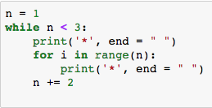

- How many asterisks will the following Python code print? _________
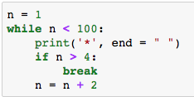

- The following Python code prints __________
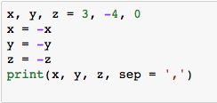

- The following Python code prints __________
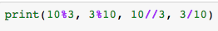

- The following Python code prints (2 answers) __________
__________
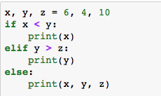

- The following Python code prints __________
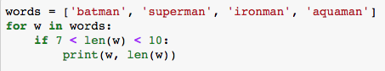

- The following Python code prints __________ assuming 2 and 22 are entered for a and b, respectively.
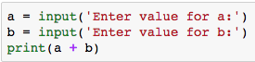

- The following Python code prints __________
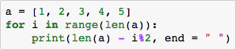

- The following Python code prints _____________________ if 1 2 3 4 5 6 7 8 9 are entered by a user.
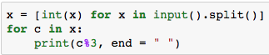

- Consider the following Python code. What are the outputs if 5, 9 and 17 are entered?
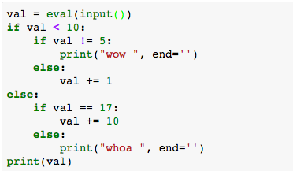

Input = 5, output = ____________
Input = 9, output = ____________
Input = 17, output = ____________

- The following Python code is developed aiming to print 2 4 6 8 on the screen. However, it does not produce the intended result. What Python statement should be added to fix the issue?

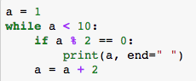

Expected output is: 2 4 6 8

- (2 marks) Trace the following Python code and fill in the blank.

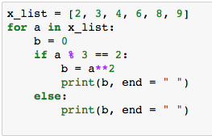

a | if a % 3 == 2  (True or False) | print(b, end = " ")

- (3 mark) How many times will list x be printed on the screen? What are the values in list x for each print?

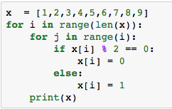

How many times? ____________

For each time, print(x) = ________________________________________
________________________________________
________________________________________
________________________________________
________________________________________
________________________________________
________________________________________
________________________________________
________________________________________
________________________________________
________________________________________
________________________________________
________________________________________
________________________________________
________________________________________

