Worksheet 10
Functions and Logic

1) Write a function, namely print2shortest(w1, w2, w3), that takes three strings (words) as input parameters. This function returns two shortest strings (words). Then write a Python to take three strings from a user and call print2shortest() function.

2) Modify the function in the exercise # 1 to print the longest and shortest strings (out of three input strings).

3) Write function, namely printshortlongfromlist(word_list), that takes a List of strings (words) as an input parameter. This function returns the shortest and the longest strings from the list.

4) What does the following Python function do?
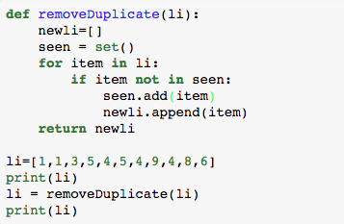
- What is the purpose of seen.add(item)? ________________________
- What is the purpose of newli.append(item)? ____________________

- Modify the code to replace the duplicated value with 100 times of that duplicated value. For
example, 1 will be replaced by 100.

5) The following python code encrypt the message by shifting the characters’ position by the number (shift) you enter. The following code can correctly encrypt alphabets (numeric and punctuation marks are not supported.

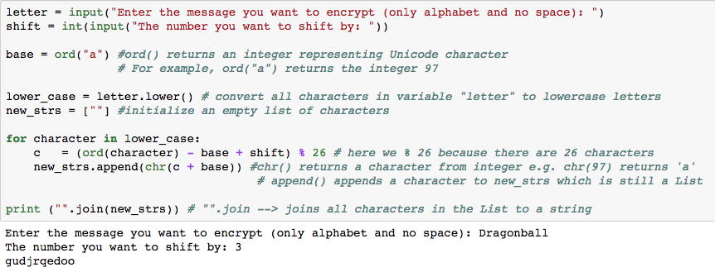

- Convert the above code into function, namely easyencrypt(letter, shift), that takes two inputs; letter and shift. The function should return encrypted text and then you can print it out on the screen. Expected output is as follows:

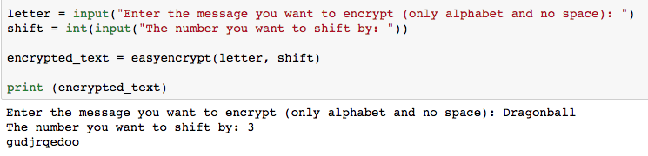

6) Extend the easyencrypt(letter, shift) function to handle uppercase/lowercase letters, numeric, space and punctuation marks. Expected output is as follows:

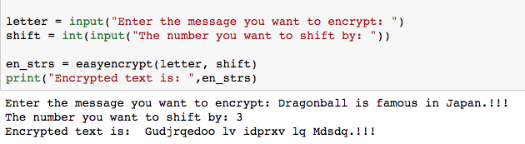

7) Write a function, namely easydecrypt(en_strs, shift), that takes the encrypted text and shift value, and then decrypt the letter. If you can successfully write a function to encrypt, to decrypt a text is just a matter of reverse operation. Expected output is as follows:

