Introduction to Data Analysis with Pandas

Visit

https://www.analyticsvidhya.com/blog/2016/01/complete-tutorial-learn-data-science-python-scratch-2/

for online tutorial.

To begin with data exploration, Python codes shown in the tutorial supports Python V2.7. Since we are using Python V.3, a slight modification to the code is required.

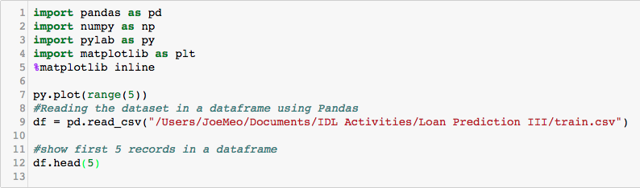

If done correctly, you should see the following results in your Jupyter notebook.

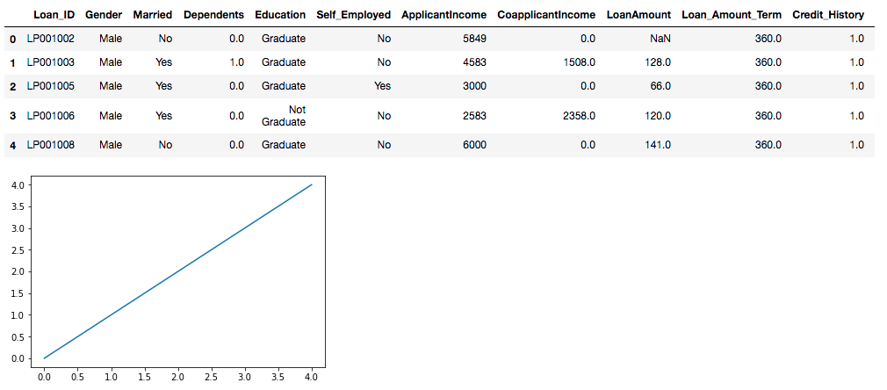

After this, you can carry on with the tutorial starting from QUICK DATA EXPLORATION.

Skip Categorical Variable Analysis when you arrive this section and continue with Data Munging.

