Worksheet 3

1) Trace the value of each variable for the following Python code
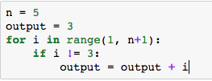

n | i | output

2) Trace the value of each variable for the following Python code
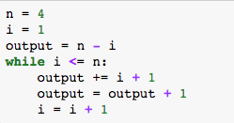

n | i | output | condition  i <= n

3) Write a Python code that takes an integer, namely my_num, and then iteratively print the values starting from my_num down to the last integer which is greater than 0. For each iteration, the value of my_num is decreased by 3.

4) To compute 1 + 3 + 5 + 7 + 9 + 11, fill in the blank
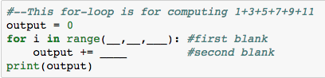

first blank = ______
second blank = _______

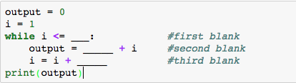

first blank = ________
second blank = __________
third blank = _________

- You may observe that both Python codes (for-loop vs. while loop) can produce the same output. Modify the above Python codes to compute 0 - 1 - 2 - 3 - 4 - 5 - … - n.

For example, if the value of n = 4, the output is 0 - 1 - 2 - 3 - 4 = -10

5) The following Python code computes (1*k) + (2*k) + (3*k) + … + (7*k)

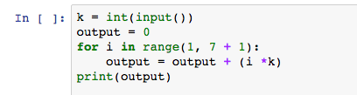

- Modify the code to compute (1*k) + (2*k) + (3*k) + … + (n*k), where n and k are inputs.

- Write a Python code using while-loop to achieve the above computation.

6) Write a Python code to take three inputs, namely n, k and v and then compute

$\frac{1*k}{v}+\frac{1*k}{v^{2}}+\frac{1*k}{v^{3}}…+\frac{1*k}{v^{n}}$

7) The following Python code computes the balance in the account with the interest rate of 10% (assume that the initial deposit is 10,000 baht). Hence after 1 year of deposit, your account balance is 11,000 baht (initial deposit = 10,000 + interest = 1,000).

- Try the following Python script and see the result.
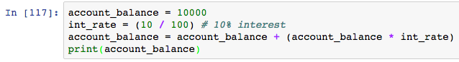

8) From exercise 5, the Python code is modified to compute the account balance after 5 years
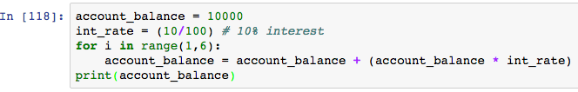

- Modify the above Python code to take the number of years, interest rate and initial account balance, and compute the account balance accordingly.
9) The following Python code prints
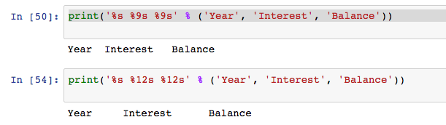
- It is known that %s in Python print( ) function will print out a string value. What is the purpose of %9 and %12 in the script? ____________________________
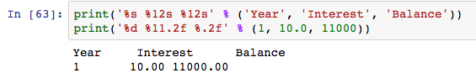

- Adjust the parameters in the second print( ) statement so that the output is shown as

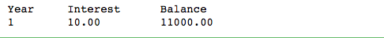

10) Based on what you’ve learned from exercises 7, 8 and 9,

Write a Python code that computes the total balance in the account after depositing for n years with the first deposit of x Baht, and the interest rate is fixed at y% (10% in this exercise) per year. The interest is calculated at each completion of one year and the interest earned is deposited into the account.

Show the result in the following format. (Assume that the first deposit is 10000)

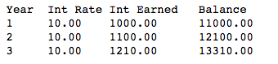

11) In exercise 10, if you use for-loop in your Python code, write a Python code using while-loop to show the result in the above format. For those who complete the exercise 8 using while-loop. Do it again using for-loop.

12) Python provides a powerful function called eval( ) that is sometimes used to facilitate obtaining input. Try the following Python script and observe how eval( ) works.

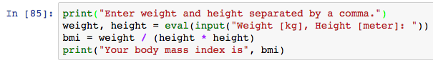

- Write a Python code to read your height [in cm] and weight [in kg] using eval( ) and print your height and weight in pounds and inches, respectively.

13) Try exercise 8 again using eval( ) to read initial account balance, interest rate and years (in one Python statement, all must be separated by comma)

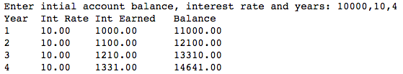

14) Write a Python code that computes the total balance in the account after depositing for n years with the first deposit of x Baht, and the interest rate is fixed at y% in the first year and is increased 1% every year. The interest is calculated at each completion of one year and the interest earned is deposited into the account. The output is shown as below as example.

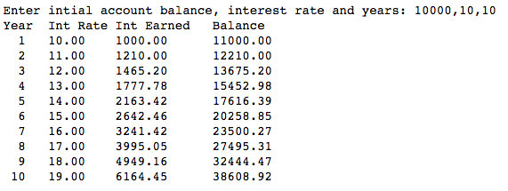

15) Write a Python code that takes an integer, namely my_int, and then print the outputs ranging from my_int to zero. For odd iteration, the value of my_int is decreased by two and for even iteration the value of my_int is increased by 1. Assume that the first loop is an odd iteration. Also draw a flowchart of your code.

