Worksheet II

- Try
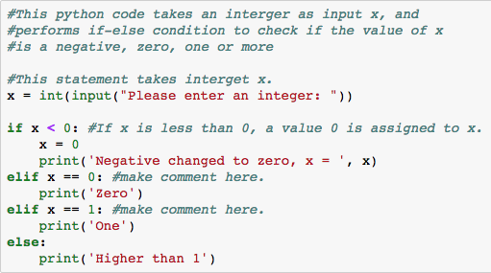

- Write a Python code that takes two integers a and b, then prints out the value of variables a and b. After that change the value of a and b to 20 and 30, respectively, and print outs the value of variables a and b.

A sample of a code

a = int(input(“Please enter a value for a: ”))

###You might observe that variable’s name can be any, for example, a, b, x and y. ###However, best practices are always to define variables’ name using recognizable words such as #my_name, my_id.

- Write a Python code that takes two integers, x and y. Then print out only the lowest value.
Hint: You need to define a simple if-else condition to check if x is greater than y (then y is the smallest value), then print out the value of y. Otherwise (or else), print out the value of x.

- Write a Python code that takes three integer x, y and z. Then print out the integer that has the value between the lowest and highest values.

- Try the following Python code.
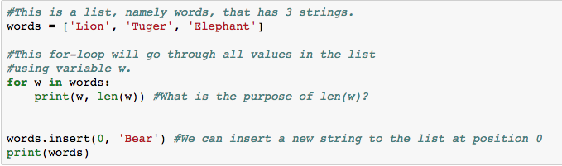

- What do you observe from using a built-in function .insert( )? ______________________________

- Try to insert more strings to the list at different position.

- Find a way to correct the word ‘Tuger’ to ‘Tiger’. A Python code must be answered here.

- Fill in the blank to calculate n! (factorial of n, e.g., 4! = 4*3*2*1 = 24)
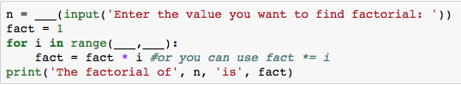

- Try the following Python code.
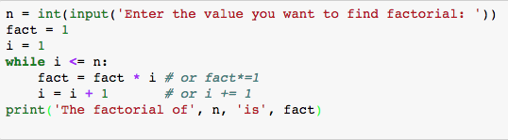
- Take note on the differences between codes in question 3) and question 4)
- Try the following Python code.
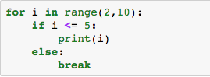

- What does function break for? ______________________________________

- Write a Python code that takes an integer a. Then compute the largest factorial that is less than or equal to a.

- Try the following Python code
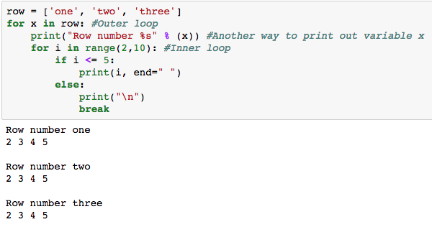

- At which loop does a function break execute? ___________________________

- Modify the code to produce the following outputs.

- Try the following Python code
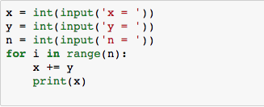

- This program computes _____________________________________________

- To compute $1+\frac{1}{r}+\frac{1}{r^{2}}+…+\frac{1}{r^{n}}$ , fill in the blank
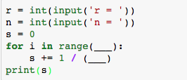

- Write a Python code to compute 2 + 2m + 2m² + 2m³ + … + 2m^{n}

- Try the following Python code.
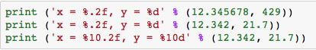

- What is the purpose the difference between %.2f and %10.2f ?
___________________________________________________________________________

- Write a Python code that takes two integers, x and y, which are real numbers. Then print x with 3 digits after decimal point and print y with 2 digits after decimal point.

- Write a Python code that takes two integers, x and y, which are real numbers. Then print both with 8 characters (including spaces) with 2 digits after decimal point for x and 1 digit after decimal point for y.

- Write a Python code that computes the total balance in the account after depositing the money for n years with the first deposit of x Baht, and the interest rate is fixed at y% per year. The interest is calculated at each completion of one year and the interest earned is deposited into the account.

Show the result in the following format. (Assume that the first deposit is 20000 and the money has been deposited for 3 years)
Year Interest Rate Interest Earned Balance
1 10 2000.00 22000.00
2 10 2200.00 24200.00
3 10 2420.00 26620.00

