Worksheet IV

1) Write the Python code to print the following outputs. Assume that 2015 is entered as shown in the example.
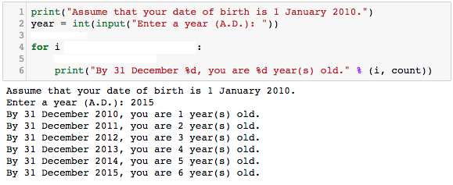

2) Rewrite the above Python code using While-Loop.

3) Write the Python code that asks for your year of birth and print the outputs as shown in the examples below.
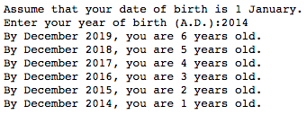

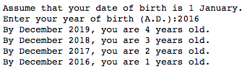
Hint: use range(start, end, -1) to start the range from a higher value down to a lower value with a
step -1. For example, range(5, 1, -1) is equivalent to 5, 4, 3, 2

4) Rewrite the Python code in exercise 3) using while-Loop.

5) Do the following two Python for-loop codes produce the same output? If the answer is NO, correct the codes in the second for-loop to produce the same output.
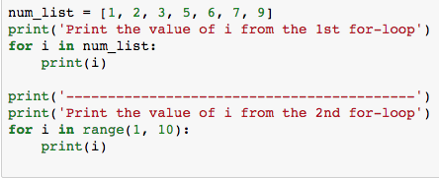

6) What does the following Python code print?
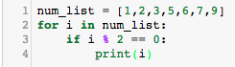
_______________________________________________________________________________________
_______________________________________________________________________________________

7) Modify if-else condition in line #3, in exercise 6), to print 3 and 6 only.

8) Modify if-else condition line #3, in exercise 6), to print a number that is higher than or equal to 3, but less than 7.

9) Modify if-else condition in line #3, in exercise 6), to print 5 and 9 only.

10) Modify the following Python code in 9) to print a name from the name_list if the third character of the name is alphabet ‘o’.
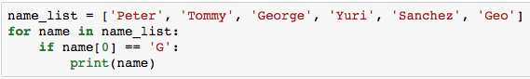

The outputs should be ‘George’ and ‘Geo’.

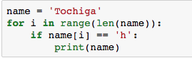
The above for-loop will go through each character in the variable, name. It then checks if a character ‘h’ appears in the variable, name. If yes, it prints that name on the screen.

11) Based on the above sample Python code, modify the Python code in 10) to include the above sample code so that the code prints me in name_list that contains character ‘e’.

12)
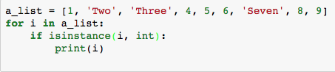
- What does the above Python code do?
- What is the purpose of the built-in function isinstance(x, int)? (Google to find the answer)

13) Modify the above Python code to print ‘Two’, ‘Three’ and ‘Seven’ on the screen.

14) Based on the following Python code,
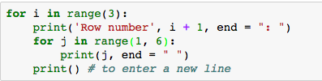

- Modify the code to print 9 rows each with values 1 to 9.
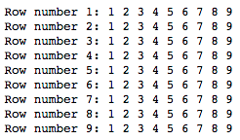
15) Modify the code again to print odd rows (rows no. 1, 3, 5, 7 and 9) with even values (2, 4, 6, 8) for each low.
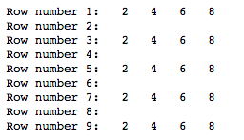

15) Modify the code again to print rows (1, 5 and 9) with values (1, 5, 9) for each low.
