Worksheet 5

Expression | Meaning
x == y | True if x = y (mathematical equality, not assignment; otherwise, false
x < y | True if x < y; otherwise, false
x <= y | True if x ≤ y; otherwise, false
x > y | True if x > y; otherwise, false
x >= y | True if x ≥ y; otherwise, false
x != y | True if x ≠ y; otherwise, false
Examples
10 < 20 True
10 >= 20 False
x < 100 True if x Is less than 100; otherwise, False
x != y True unless x and y are equal

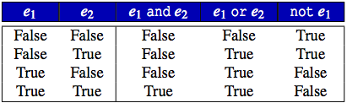

Operator not has higher precedence than both and and or.
and has higher precedence than or.
and, or are left associative; not is right associative.
and, or have lower precedence than any other binary operator except assignment.

- Fill in the blank
x = 10
y = 20
b = (x == 10) # assigns True to b
b = (x != 10) # assigns False to b
b = (x == 10 and y == 20) # assigns ________ to b
b = (x != 100 and y == 30) # assigns ________ to b
b = (x == 10 and y != 20) # assigns ________ to b
b = (x != 10 or y != 30) # assigns ________ to b
b = (x == 10 or y == 20) # assigns ________ to b
b = (x != 100 and y == 30) # assigns ________ to b
b = (x == 10 or y != 20) # assigns ________ to b
b = (x != 10 and y != 30) # assigns ________ to b

- Given the following definitions
x = 3, y = 2
b1, b2, b3, b4 = False, True, x == 3, y < 3 # This statement assigns Boolean value in
# accordance with the order of the appearance, e.g., # b1 is assigned value of False. x == 3 is True,
# hence b3 is assigned a Boolean value of True.

Evaluation the following Boolean expressions (True or False)
b1 or b2 and b3 ______________
b1 and b2 and b3 ______________
b1 or b2 or b3 ______________
not b1 and b2 and b3 ______________
not b1 or b2 or b3 ______________
not (b1 and b2 and b3) ______________
not (b1 or b2 or b3) ______________
not b1 and not b2 and not b3 ______________
not b1 or not b2 or not b3 ______________
not (not b1 and not b2 and not b3) ______________
not (not b1 or not b2 or not b3) ______________

Nested If-else
The if...else statement executes two different codes depending upon whether the Boolean expression (if-else condition) is true or false. Sometimes, a choice has to be made from more than 2 possibilities. The nested if...else statement allows you to check for multiple test expressions and execute different codes for more than two conditions.
As an example, in Python (or any other programming language), there may be a situation when you want to check for another condition after a condition resolves to true. In such a situation, you can use the nested if construct. In a nested if construct, you can have an if...elif...else construct inside another if...elif...else construct.
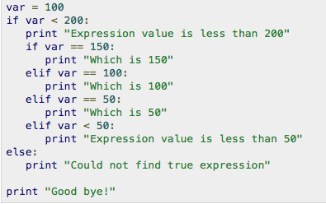
- In the above example, what would be printed on the screen? __________________________________________________________________________________
- Write a Python code to take 2 numbers for variable names, var1 and var2. If the value of var1 is equal to that of var2, print “(value of var1) is equal to (value of var2)”. For example if you enter 10 and 10 for var1 and var2, the code will print “8 is equal to 8”.
The code will print “(value of var1) is greater than (value of var2)” if var1 > var2, and vice versa. Solve this problem using nested if-else. Hint: you should first check if the two values are not the same, then you can if another if-else to check if var1 > var2 or var2 > var 1 under the first if statement.

- The following table illustrates the grip strengths (on average) based on Gender. In general, the dominant hand will often score 10 percent higher than the non-dominant hand. Write a Python code to take a gender (capital M or F) and grip strength in kg., and then print out the strength level. For example, if you enter M and 50 as inputs, the code should print “Your grip strength is average.”
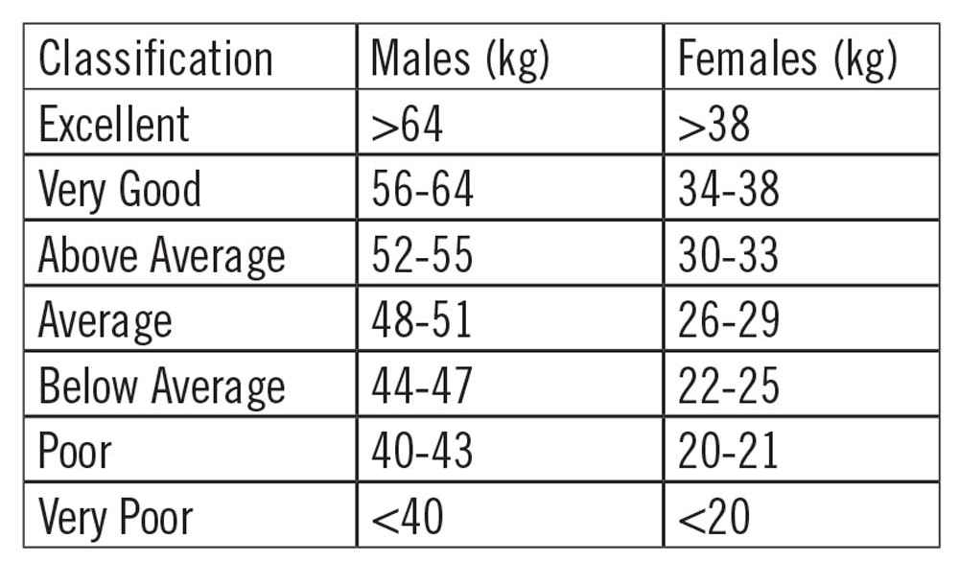
Examples:
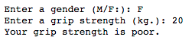 and 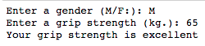
- Write a Python program to take name, gender, age as inputs and print out the growth stage of that person.

Age | Growth Stage
< 11 | Children
11 to 17 | Adolescence
18 to 40 | Young adult
41 to 65 | Adult
> 65 | Elderly

Examples of inputs and outputs
and 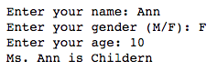

- Write a Python code that takes two integers, a and b. Then print all integer between these two numbers (including a and b). Note that any integer ended with 3 and 7 will be replaced by *. For example, if you enter 2 and 12 for a and b, the code will print
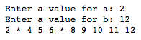

If you enter 2 and 28, the code will print
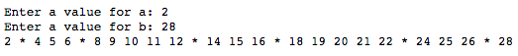

- Write a Python code to print all integer numbers between 0 and 30 with the following conditions:
  - All printed numbers must be divisible by 3 (otherwise, * symbol is printed), and
  - the number between 10 – 15 and 20 – 25 will be replaced by an underscore symbol.
Expected output is given below.

- Write a Python code to print integers between 100 and 200 with the following conditions:
  - The right-most digits must be even number,
  - the integers that is divisible by 5 will not be printed,
  - 0 is considered as an even number, and
  - all the printed integers between 130 – 140 and 160 – 170 will be replaced by @ sign.

- Based on the given Python code, modify the code to print the number where all digits are even number. Otherwise, -- will be printed as shown in the expected output below.
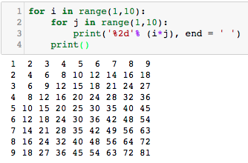

1st expected output (only even numbers):
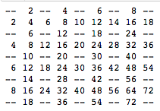

2nd expected output (only even numbers and both digits must be even numbers):
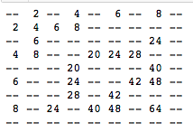

3rd expected output (only first row and first column printed)
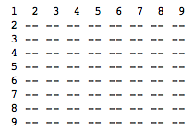
4th expected output (only first and last rows, and first and last columns printed)
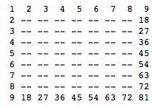
5th expected output (based on 4th output but integers appeared in diagonal lines printed)
