Worksheet VI

You have learned a number of methods for taking inputs from a user. You can use either input( ) or eval( ) functions to read a single input or multiple inputs in one line of code. These built-in function takes a single input for each individual variable. There is another method to read multiple inputs and place them into a list.

- The following Python code takes multiple inputs and stores them in a list.

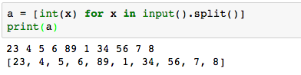

- Write a Python code that takes multiple integer inputs and prints out the maximum, minimum and average values.

- Write a Python code that takes multiple integer inputs and asks if a user prefers to find a sum of either odd, even or all numbers (your code must show a user three options to choose) and print the value on the screen.

- Write a Python code that takes multiple inputs and prints all the values which are greater 10 but less than 50. The number must be even number and divisible by 6 (for example, 12, 18, 24).

You can apply while-loop statement to continuously run the code until the condition defined in While statement returns False. See the following exercise.

- Try the following Python code which receives two inputs, namely name and yourid. The code asks whether or not you want to have your name and id printed on the screen. This operation continues until you enter either n or N to end the program.

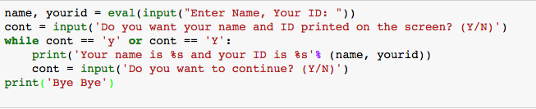

- Write a Python code to calculate BMI and the code keeps asking you to continue until you enter n or N to end.

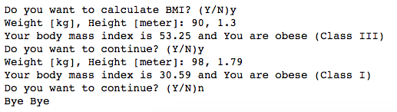

When you are working with string variable, you are able to refer to each character in the string using For-loop statement. In the following example, a number of vowel letters (either capital or small letters) is counted.

First of all, you need to define a list of characters you want to count. This can also include special characters. Try

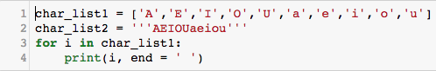

You will notice that, in each loop, variable i retrieves elements from char_list. In line no. 3, change from char_list1 to char_list2 and run again.

You will notice that both codes return the same outputs. As you may see, using ‘’’ ‘’’ might be a bit more convenient in the number of elements in the list is very long. Now let’s see what should be done if we want to count vowel letters in the sentence. First, you need to read a sentence as an input. In Python, a sentence (string of words) is still string variable.

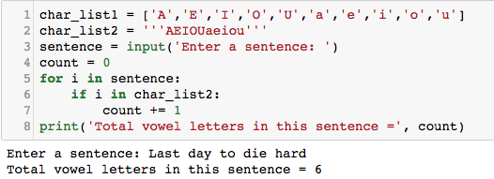

What happened here is that we take strings (a sentence from a user) and then we define one variable, namely count, which will be used to count the number of vowel letters. Then we use For-loop to go over list. Inside the loop, we use if-condition to check whether the character (stored in variable i) is in char_list2 or not. If yes, we increase the value variable count by 1.

- Write a Python code to take a sentence and a character that you want to count. Expected inputs and output are

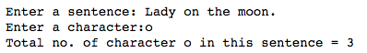

- Write a Python code to take a sentence and a character that you want to count. The code keeps asking you to continue until you enter n or N to end. (You need a code from exercise 2)).

The following Python code counts the number spacebar appeared in a sentence. We use for-loop to go over my_sentence. If a character (stored in variable i) is spacebar, we increase the count by 1.

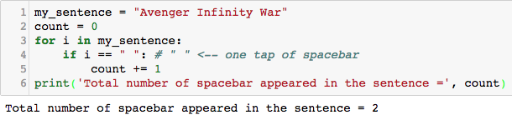

- Write a Python code to take a sentence and count the number of characters, excluding spacebar and vowel letters. Expected input and output is as follows:

- Write a Python code to count a number of vowels, consonants, spacebar, digits in the sentence.

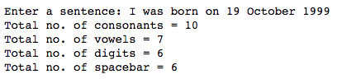

- Note that the above exercise does not include special characters such as period, question mark, dollar sign, etc.. Modify the code to also count these special characters.

- Modify the code to calculate the total sum of digits appeared in the sentence. Note that you can convert string to integer using int(). For example, if variable i is a digit with string type, int(i) will return an integer value of that digit.

