Worksheet 10
Functions and Logic

1) Write a function, namely return2shortest(w1, w2, w3), that takes three strings (words) as input parameters and returns two shortest strings (words) as outputs. Then write a Python code to take three strings from a user and call print2shortest() function.
Example: Assume that you have entered the following words (using input() function) for w1, w2 and w3

w1 = input(‘Enter a word: ’) ----- assume that you have entered ‘Ironman’
w2 = input(‘Enter a word: ’) ----- assume that you have entered ‘Batman’
w3 = input(‘Enter a word: ’) ----- assume that you have entered ‘Paman’
out1, out2 = return2shortest(w1, w2, w3)
print(out1, out2)

Expected outputs are: Paman, Batman

2) Modify the function in the exercise # 1 (change a name to printshortlong(w1,w2,w3) ) to determine the longest and shortest strings (out of three input strings) and print the two strings inside the function.

3) Write function, namely printshortlongfromlist(word_list), that takes a List of strings (words) as an input parameter. This function returns the shortest and the longest strings from the list.

4) What does the following Python function do?
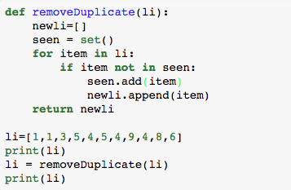
- What is the purpose of seen.add(item)? ________________________ (Google for the answer)
- What is the purpose of newli.append(item)? ____________________

- Modify the above function (change the name of the function to 100xDuplicate(li) ) to replace the duplicated value with 100 times of that duplicated value. For example, 1 will be replaced by 100. Note that the first appearance of an integer remains unchanged.

For example, li = [1,1,3,5,4,5,4,9,4,8,6]
out_li = 100xDuplicate(li)
print(out_li)

The expected output: 1, 100, 3, 5, 4, 500, 400, 9, 400, 8, 6

5) The following python code encrypt the message by shifting the characters’ position by the number (shift) you enter. The following code can correctly encrypt alphabets (numeric and punctuation marks are not supported.

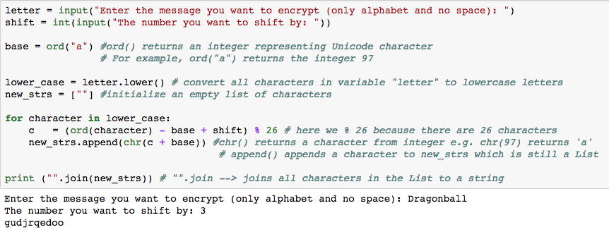

- Convert the above code into function, namely easyencrypt(letter, shift), that takes two inputs; letter and shift. The function should return encrypted text and then you can print it out on the screen. Expected output is as follows:

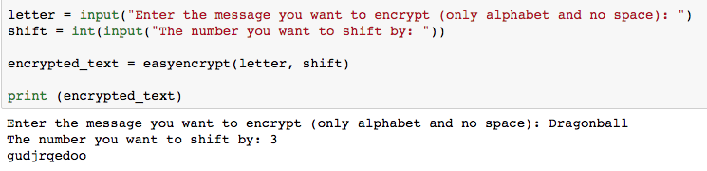

6) Extend the easyencrypt(letter, shift) function to handle uppercase/lowercase letters, numeric, space and punctuation marks. Expected output is as follows:

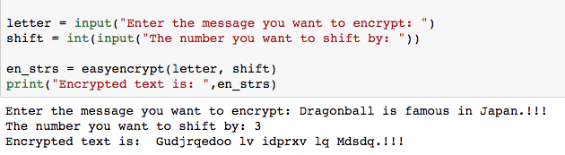

7) Write a function, namely easydecrypt(en_strs, shift), that takes the encrypted text and shift value, and then decrypt the letter. If you can successfully write a function to encrypt, to decrypt a text is just a matter of reverse operation. Expected output is as follows:

