Worksheet 8

- Try

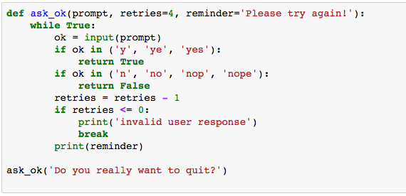

- How many attempts can you try if you do not answer correctly (e.g., enter any character other than ‘y’ or ‘n’)? ___________________
- Which argument in function ask_ok() does determine the number of attempts? _______
- How many arguments are there in function ask_ok()? _________

Try

ask_ok('OK to overwrite the file?', 2)

- What do you observe here in terms of number attempts?
_____________________________________________________________

Try
ask_ok('OK to overwrite the file?', 2, 'Come on, only yes or no!')

- What do you observe here? ___________________________________________________________

- What do you observe from the number of arguments you can enter when you call a function? ___________________________________________________________

- x = [3, 1, 56, 34, 23, 100, 10], write a function that sorts list x (low to high) and print it out. Do not use Python built-in functions!!!!

- From list x in the exercise 7), try sorted(x) and sorted(x, reverse=True)

- Also try, x.sort() or x.sort(reverse=True), then print(x)

As of you may notice now, Python offers several ready-to-use built-in functions. We do not need to waste our time if we know how to use them.

Nevertheless, it is also good to be able to solve the problems without using such built-in functions as some programming languages may not have these ready-to-use functions.

- Write a function, namely removevowel(input_str), that takes string as an input and removes all vowel letters from the string. The removed vowels are replaced by under scroll sign. The function returns the string after the vowel letters are removed. Write a Python program that asks if users want vowel letters to be removed from the entered string. If yes, call removevowel(input_str).

Hint: The following Python function replaces characters “a” and “b” with “=” sign.

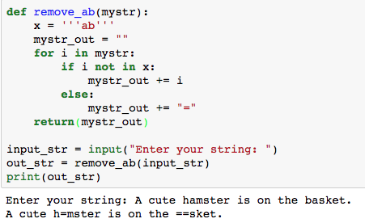

Note: In Python, you can use either this syntax [“a”, “b”] or '''ab''' to identify a list of characters as shown in the example.

- Extend the function to remove also all numerical values including positive and negative sign from the string. For example,

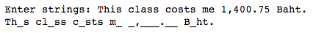

- Write a function, namely doubletriple(x), that takes an integer and returns 3 values; a value x, double of value x and triple of value x. Then print the three values on the screen.

- Write a function, namely findsumavg(list_x), that takes a list of values (either integer or floating point values) and calculates the summation and average values of the values in the list. Then returns these two values from the function. Then write a Python program to take multiple integer or floating point values from users and call findsumavg(list_x), and print the summation and average values on the screen.

- Write a function, namely mynameid(), that takes your name and id as inputs. Write another function, namely mybio(), that takes your height and weight as inputs. Insider mybio(), call mynameid(), calculates BMI values and then print your name, id, height, weight and BMI values on the screen.

Introduction to Anonymous Lambda Function in Python

In Python, anonymous function is a function that is defined without a name.

While normal functions are defined using the def keyword, in Python anonymous functions are defined using the lambda keyword.

Hence, anonymous functions are also called lambda functions.

Syntax of Lambda function:

lambda arguments: expression

Here is an example.

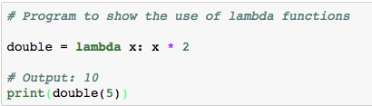

In the above program, lambda x: x * 2 is the lambda function. Here x is the argument and x * 2 is the expression that gets evaluated and returned.

This function has no name. It returns a function object which is assigned to the identifier double. We can now call it as a normal function. The statement

double = lambda x: x * 2

is nearly the same as

def double(x):

return x * 2

We use lambda functions when we require a nameless function for a short period of time.

In Python, we generally use it as an argument to a higher-order function (a function that takes in other functions as arguments). Lambda functions are used along with built-in functions like filter(), map() etc.

The filter() function in Python takes in a function and a list as arguments.

The function is called with all the items in the list and a new list is returned which contains items for which the function evaluates to True. Here is an example use of filter() function to filter out only even numbers from a list.

Try

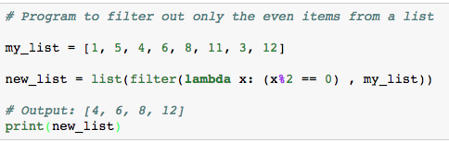

- Write a lambda function that takes a string and filter out all vowel letters from the string. Then print the new string out.

Example use with map()

The map() function in Python takes in a function and a list.

The function is called with all the items in the list and a new list is returned which contains items returned by that function for each item.

Here is an example use of map() function to double all the items in a list.

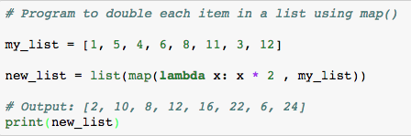

- Write a lambda function using map() to double the value for even numbers and triple the value for odd numbers in my_list.

Hint: you can write a condition in lambda function such that

lambda x: expressions if condition else expression

For example, list(map(lambda x: x + 2 if x < 2 else x + 3, my_list))

This will increase the value of x by 2 if x is lower than 2, otherwise x is increased by 3 from all the integers in mylist.

Introduction to Modules in Python

Modules refer to a file containing Python statements and definitions.

A file containing Python code, for e.g.: example.py, is called a module and its module name would be example.

How to import modules in Python?

We can import the definitions inside a module to another module or the interactive interpreter in Python.

Let us create a module. Type the following and save it as example.py in your working directory.

# Python Module example

def add(a, b):

"""This program adds two

numbers and return the result"""

result = a + b

return result

Here, we have defined a function add() inside a module named example. The function takes in two numbers and returns their sum.

We use the import keyword to do this. To import our previously defined module example, we type the following in the Python prompt. Try

Import example

example.add(4,5)

In this above example, we have created our own module and import the module to be used in our Jupyter notebook. Note that you need to open a new notebook to try this example.

Python has a ton of standard modules available.

You can check out the full list of Python standard modules (https://docs.python.org/3/py-modindex.html) and what they are for. These files are in the Lib directory inside the location where you installed Python.

Standard modules can be imported the same way as we import our user-defined modules.

There are various ways to import modules (as a whole module). They are listed as follows.

# import statement example

# to import standard module math

import math

print("The value of pi is", math.pi)

or

# import module by renaming it

import math as m

print("The value of pi is", m.pi)

We can import specific names form a module without importing the module as a whole. Here is an example.

# import only pi from math module

from math import pi

print("The value of pi is", pi)

Study https://www.programiz.com/python-programming/modules for more details about importing modules in Python.

- Write a module, namely myvalue and define two functions, which are doublevalue() and triplevalue(). The two functions take parameter x and double and triple the value of x.

Then import the module and try the two functions.

- Write a module called mysimplemath and defines four functions, namely add(), subtract(), multiply() and divide().

Then write a Python code that imports mysimplemath. Then the code asks for two inputs and one operand (+, -, *, /). Call the function in correspond to the given operand.

