CS1201 Computer Programming I (Section 542)
Mini Project
Data Visualization with Pandas

Based on the given ThailandProvince.csv and ThailandProvinceTax.csv (these two files can be downloaded from the portal) complete, but not limited to, the following instructions:

- Import necessary modules

- Load data from ThailandProvince.csv and ThailandProvinceSector.csv to dataframe variables called tp and tp_sector, respectively.

- Show five records from tp and two records from tp_sector.

- Merge two dataframes

- Sort the data based on ‘Code’ and show the first 20 records.

- Count the values by ‘Sector’. The expected output is
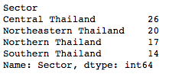

- Show Scatter plot with x-axis = Longitude and y-axis = Latitude

- Import cartopy and show Scatter plot on Thailand map. The figure size should be (36,18) or other values that map’s size is big enough.

- From the merge data, create four dataframes; tp_north that contains only northern provinces, central that contains only central provinces, tp_northeastern that contains only northeastern provinces and tp_south that contains only southern provinces. Then show the first 3 records of each datagrame.

- Show Scatter plot for each sector with different colors for makers.

- Write a Python code to plot the following graph.
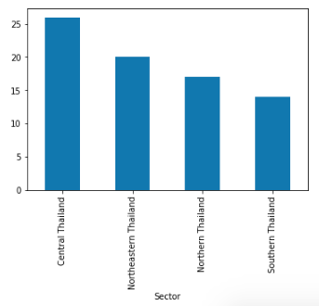

- Write the python code to plot the following Pie.
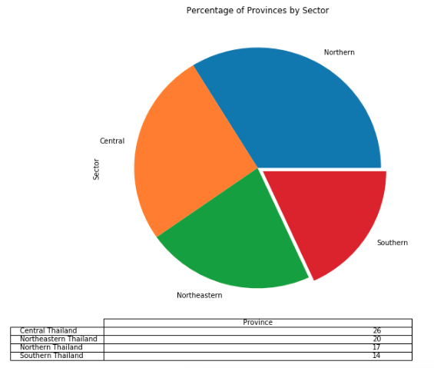

- If you just complete the above instructions, you will get 60% of your points. Based on what you have learned from the worksheet. Show as much interesting data visualizations as you can imagine.

