Practices for Practical. Note that you need to know how to do basic data analytics and visualization using Pandas (Worksheet 11 and 12)

- Write a function, namely ishalfofmyintlist(my_intlist, my_int), that takes a list of integers and an integer you want to count as inputs. Then the function determines if the total amount of the integer value you want to count is less or greater than half of the list size, and print the following statement as shown in the examples below.

Examples of input(s) and output(s)
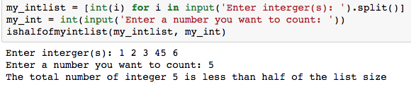

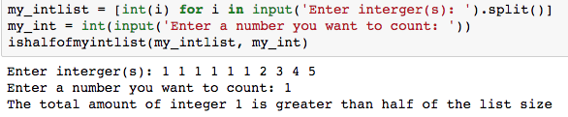

- Write a lambda function that doubles the value of all even numbers and -1 from all odd numbers.

For example: input_list = [1, 2, 3, 5, 6, 7, 8, 9]
output_list = your_lambda_function_here.
The output should be [0, 4, 2, 4, 12, 6, 16, 8]

- Write a function, namely double_reverse(), that takes a list of integers as an input. The function does return a list containing all original integers, except the last one, plus integers in a reverse order.

For example: input_list = [1,2,3,4]
output_list = double_reverse(input_list)
print(output_list)

The output should be [1,2,3,4,3,2,1]

- Write a Python code that repeatedly asks a user to enter an integer number. The code will stop taking an integer number when three zeros (0) are entered. Then, the summation and average values of all entered integers are to be printed on the screen.
Practices for Written

- Write a Python code for the following Flowchart

Outputs of the following Python codes

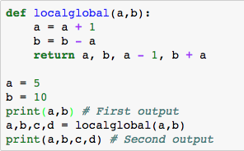

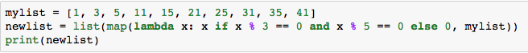

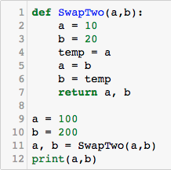

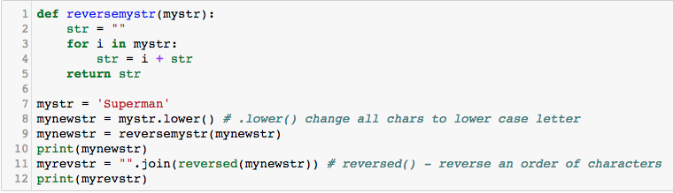

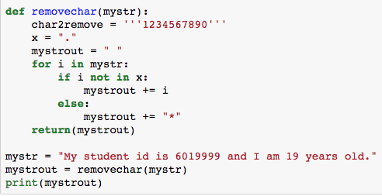

Draw Flowchart for the following Python code.
