Is Time Pressure an Advantage or a Disadvantage for Front End Innovation – Case Digital Jewelry
  - Piyanut Kupakarnchana (ID: 5829432)
Managing Innovation in Business Transformation

Is Time Pressure an Advantage or a Disadvantage for Front End Innovation – Case Digital Jewelry
  - Piyanut Kupakarnchana (ID: 5829432)

Time-pressured front end of collaborative and radical innovation

Front End Innovation (FEI)

Innovation process begins with Front End Innovation where opportunities are identified, analyzed, enriched, selected, then its concept is defined. This will turn into a new product development. This stage is considered as the most difficult part of innovation process to manage because of significant uncertainties.
This research will focus on Front End Innovation.
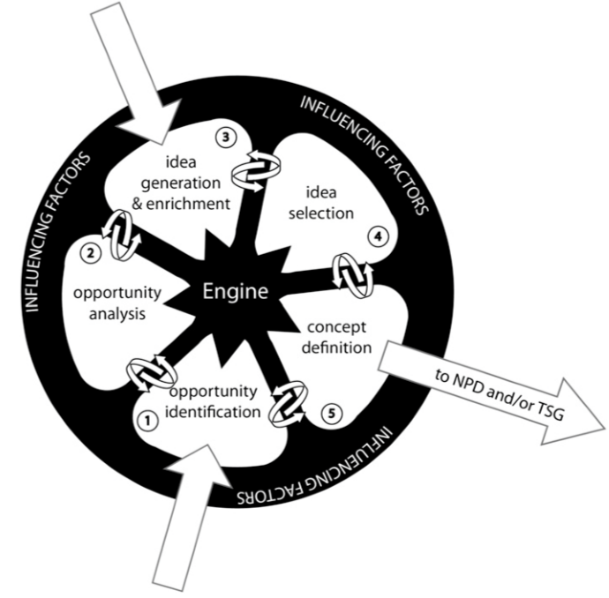

Collaboration

During collaboration, active engagement of network partners in collaboration is needed. Heterogeneous groups have been seen as an important success factor, especially for the creation of radical innovations.

Success Factors for Radical Innovations

Radical innovations usually include greater uncertainties and risks than incremental innovations. In this research, we found that success factors will most probably differ.

Time Pressure in Radical Innovations Context

According to the research’s literature review, visionary leadership, maintaining project momentum, and team collaboration have an essential impact on the success of a radical innovation project.
Leaders help in providing direction and making decision of the project. Project momentum keeps adding pressures and increases member commitment toward the innovation project goals. Collaboration within the team ensures that all members align their common goals, increase trust, and increase creativity.
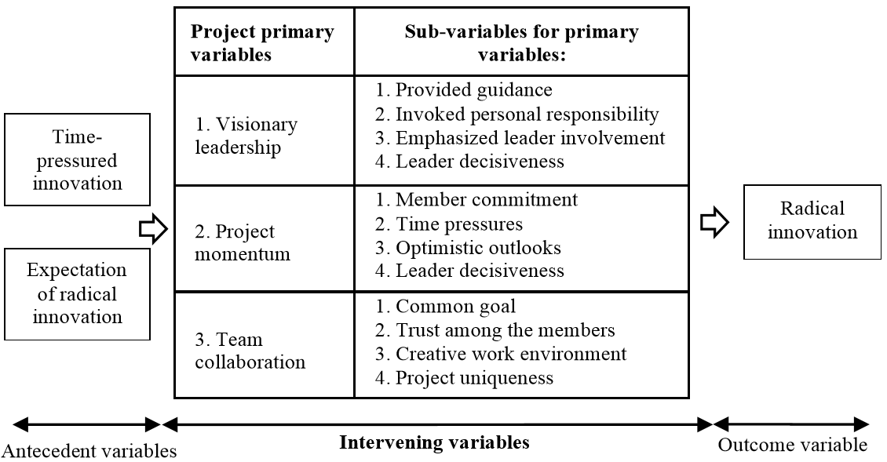

Theory of The Effect of Stress Related to Productivity and Outcomes

Stress is typically assumed by many as negative impact to the project team members. However, a theory leveraged by this research suggests that stress can be either good stress or distress.
Once level of stress arousal is increased, it will move the team members to comfort zone and significantly increases performance. This will hold true until it researches the stage that the team members are fatigued. The whole range is considered “good stress”. However, once the arousal passes fatigued level, the performance will start dropping and start causing exhaustion, ill-health and finally breakdown. This part is considered “distress”.
With proper “stress management”, the performance level before members are fatigued can be increased. Thus, stress management becomes an important norm for a successful innovation project.
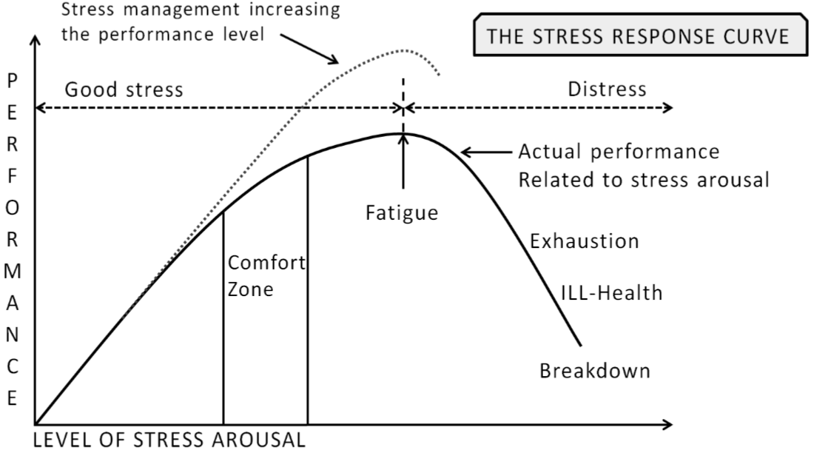

Description of the Innovation Project

The Case Study

The case study is a 3-week innovation project. Innovators are industrial representatives, researchers, academics from universities, students in polytechnics. They have 6 different knowledge areas: Jewelry industry, business, industrial management, ICT, mechanical engineering, and art. Age is between 20-45. Evaluator is a serial entrepreneur. Objective: 5 to 10 quality ideas for the dragons’ den. Below is an example of a dragon den.

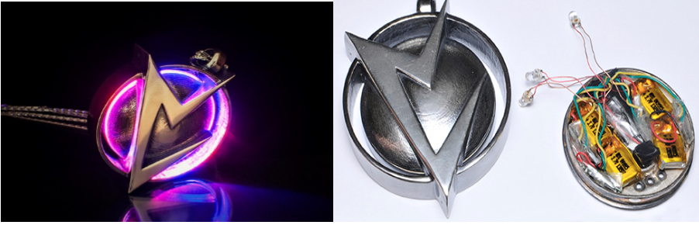

Visionary leader did not participate in the day-to-day innovation project activities at all. The 2 teams carried out the innovation tasks and were run by operative leaders. Below are the project management results.
Team#1 spent only 1 day on the project. The operative leader clearly defined timeframe to work on the project.
Team#2 spent 2 weeks on the project. No timeframe was defined by the operative leader. Each team member worked on their own with no structured collaboration. As a result, they almost could not meet the objectives.
Below is the timeline of the project.
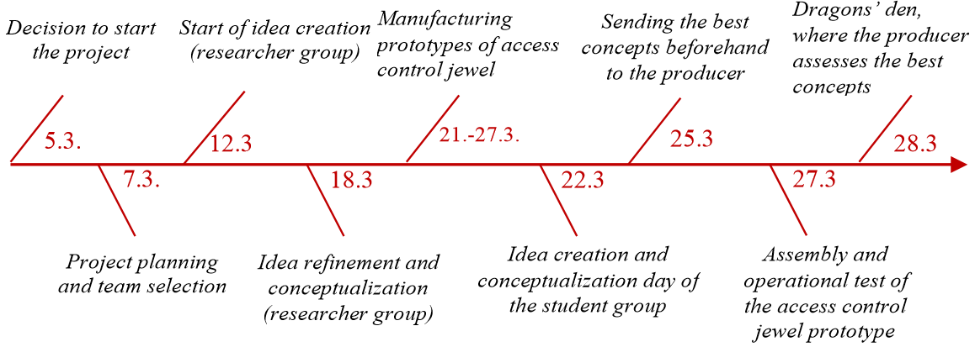

To describe how the innovation groups are communicating within the groups, the figure below shows its most important interaction relationships.

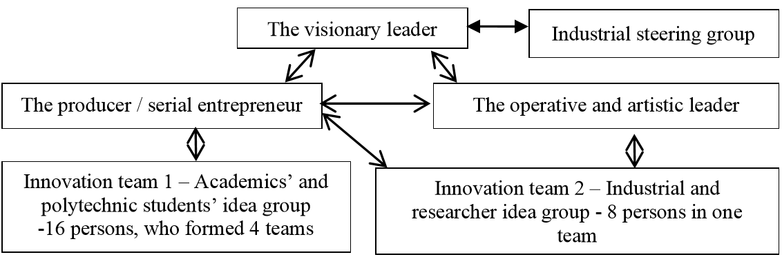

To describe the idea funnel of the innovation project, the following figure represents the results according to FEI from 203 initial ideas. Through refinement, evaluation and selection, 23 conceptualized ideas were sent to the producers for evaluation. The serial entrepreneur chose five concepts for the dragons’ den. Four of them came from the innovation team 1 and one from the team 2. The ideas that proceeded to the final stages were: mosquito/tick repellent jewel, access control jewel, sleep jewel, baby monitor jewel, and a flower stick indicating the need to water a plant. Access control jewel is the best concept.
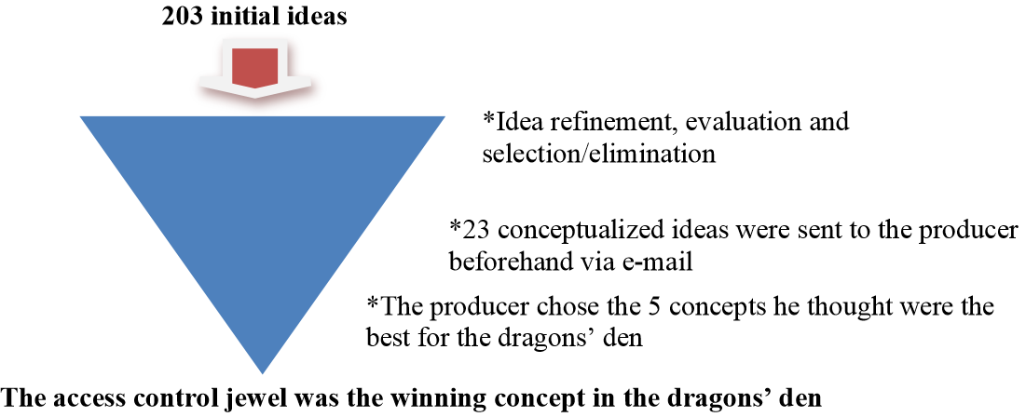
Below is the demonstration of the winning concept.
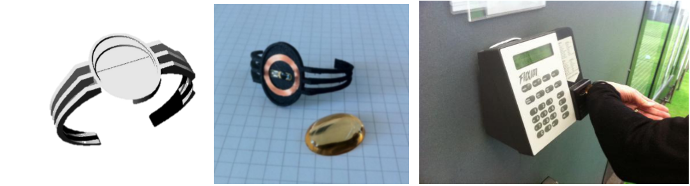

Analysis and results of the innovation project

A survey was launched to 4 participants in the project to evaluate the quality and quantity of the created ideas and concepts.
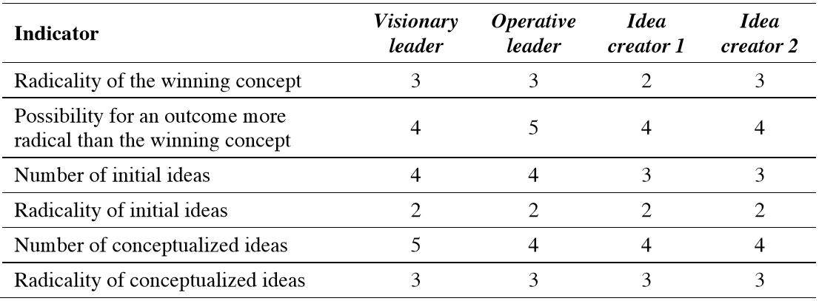
Based on the above survey results, everyone thinks that the winning concept is satisfactory. It could have been more radical. While 203 initial ideas were considered high given a limited timeframe, they were not great. Conceptualized ideas, however, are satisfactory.

Feedback from the outside evaluation group

Most significant new issues are: 1) utilization of a more multidisciplinary and international idea creation group in the creation of ideas, 2) moving away from product-centered thinking, and 3) making the serial entrepreneur a more active participant. These could have improved the quality of the innovation project significantly.

Findings: Time pressure as a source of stress in the innovation project

Based on the comments from participants in this project, the innovation team 1’s performance and stress levels were mostly higher than in the innovation team 2. It is known that innovation team 1 is out of their comfort zone and the operative leader had to push himself really hard to manage in this way.
On the other hand, the innovation team 2 did not seem to feel much pressure or stress during the process and considered producing the results “optional”. They seemed to produce results only when they felt inclined to do so which means they are still in comfort zone.
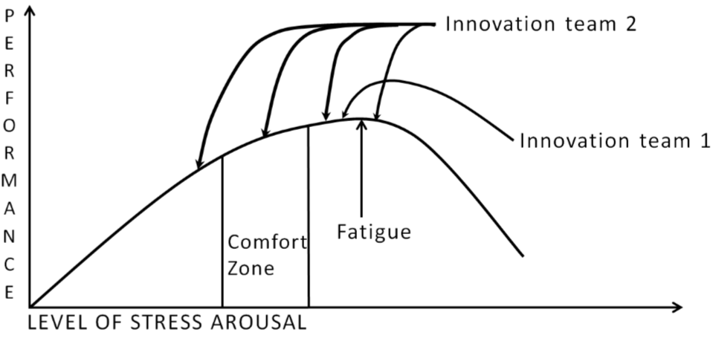

Conclusion

Success Factors of FEI

These are the four main factors to ensure that an innovation project’s FEI is successful.
- Visionary leadership
- Project momentum
- Team collaboration
- And most importantly, “positive stress” to keep group momentum in motion. There should be more facilitated stress with mentoring to the participants how to control the stress.
“Stress management” can be used as a method to increase performance level without adding on stress arousal.

Time Pressure FEI: Advantages and Disadvantages
On the positive note, most of the people were committed to the project. This creates an inspiring challenge for a group. People worked together. The focus remained on the goal. Concrete results were gained quickly. Being open was necessary. Finally, decision-making was fast.
However, time pressure FEI has its negative effect too. At times, decision making was too fast. It was difficult to organize joint face-to-face meetings. There was not enough time to provide the support and extra guidance needed. There was enough time only to make prototypes of one idea. It was not possible to expand the idea creation group. Work had to be carried out also during evenings and weekends. And ideas were not refined and combined sufficiently.

Future Studies

These are the list of future studies recommended if researchers proceed with similar projects:
- A variety of decision-making models and different decision-makers
- Methods that support radical innovation, such as TRIZ
- A heterogeneous and international group
- Only the most committed and motivated persons involved in the innovation team
- A preparatory “test” to select participants for the project
- Working methods that highly encourage people to innovate in the same space and at the same time to achieve genuine collaboration
- Methods that force people to combine their ideas with those of others, e.g. to establish whether this reduces the adverse effects of short cuts people take under time pressure
- An operational model with an even stricter schedule, which would then force innovations

Reference

[1]E. Salmela, A. Happonen, M. Hirvimäki and I. Vimm, "Is Time Pressure an Advantage or a Disadvantage for Front End Innovation – Case Digital Jewelry", Journal of Innovation Management, vol. 3, no. 4, pp. 42-69, 2015.
